Rajvi Mehta

  CSU Global

mis500 module 8 critical thinking option #2

MIS500 Module 8 Portfolio Project Option #2

Present day healthcare systems are not only intricate, but it is tremendously unlike “what it used to be”. The improvements are numerous and signify the main changes that consist of transitioning from an indemnity plan, foundation on initially what the patient wants, to a manageable care system. The American healthcare system has not just gone through a major transformation within two generations, but furthermore moves forward towards change. What are the factors that are progressing the transformation? How is healthcare performing now than how it was in the past? How are the transformations affecting the families across the country? What more can be done? What does the future have in stock for the healthcare system? All of these are essential questions that must be pondered upon as the masses age, as healthcare prices increase, as treatments become more expensive, and as more and more people are in the absence of having healthcare coverage.

This MIS500 Module 8 Portfolio Project will correct and analyze the national healthcare expenditures by type of service SAS code example. I was frankly attracted to the word ‘population’ when reading the given list of datasets. To me, the word ‘national’ meant that it could be a topic that is relatable to one and all throughout the country and something that everyone can invest their time in trying to understand for the sake of gaining a little bit of general knowledge and/or being prepared for the future of the healthcare field in relation to data analytics. I used the <https://meps.ahrq.gov/mepsweb/about_meps/sas_examples.jsp> website for the SAS code example.

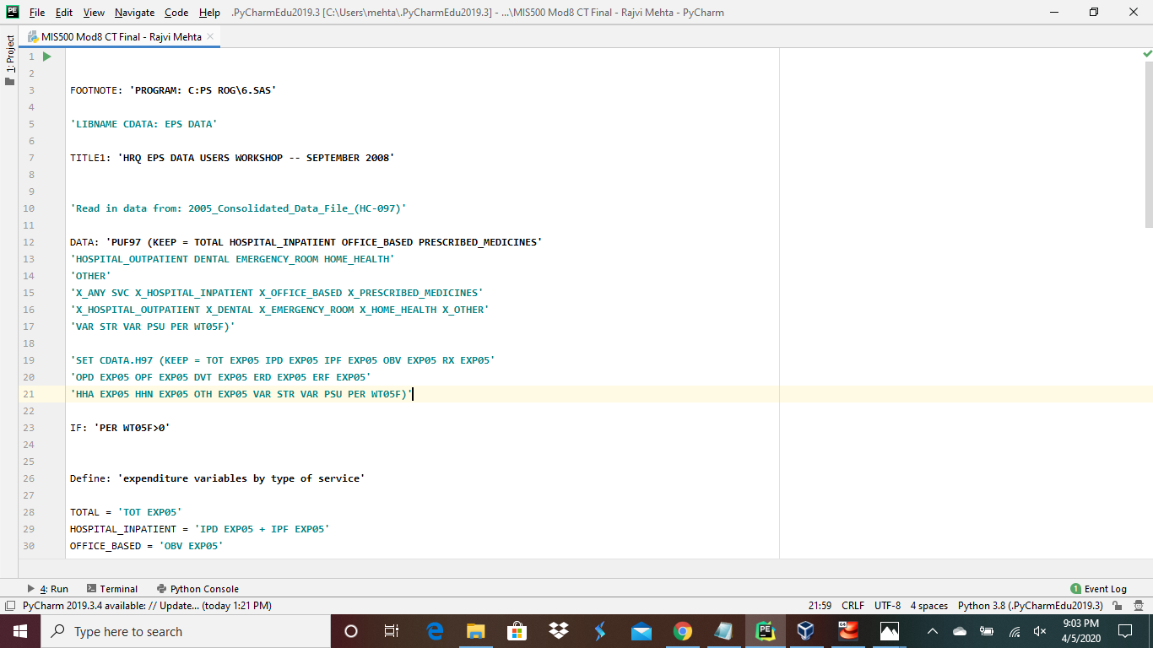

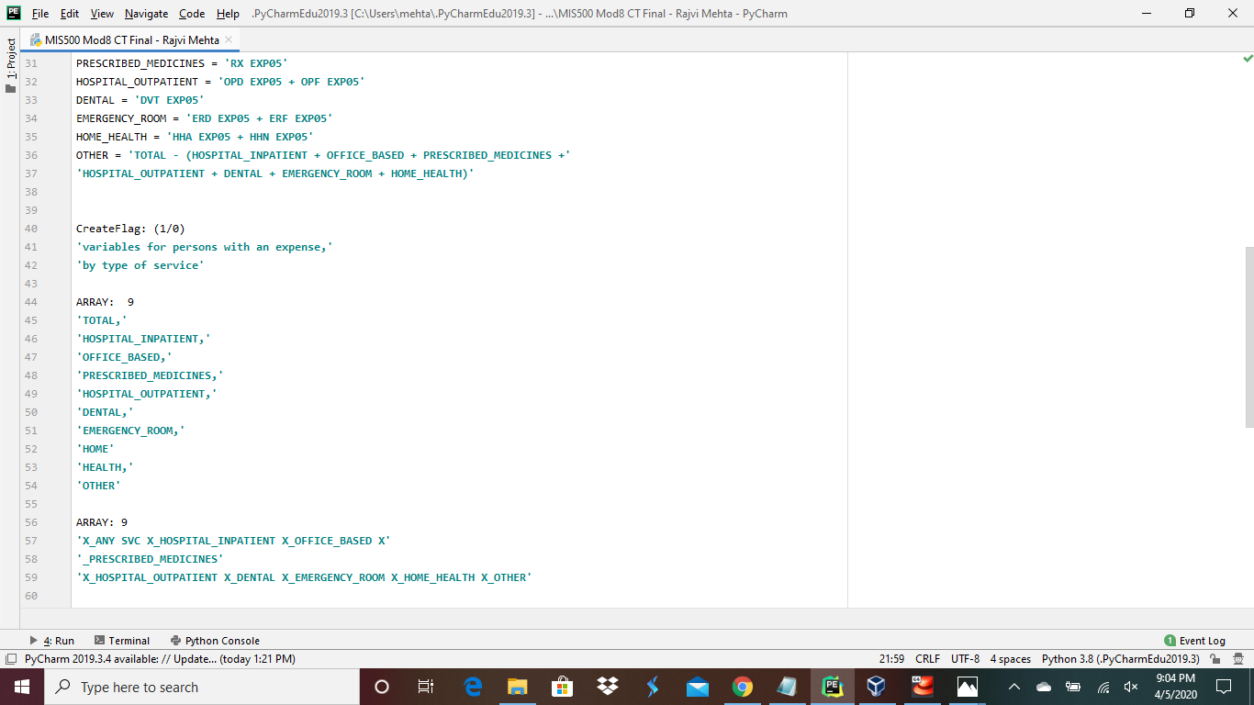

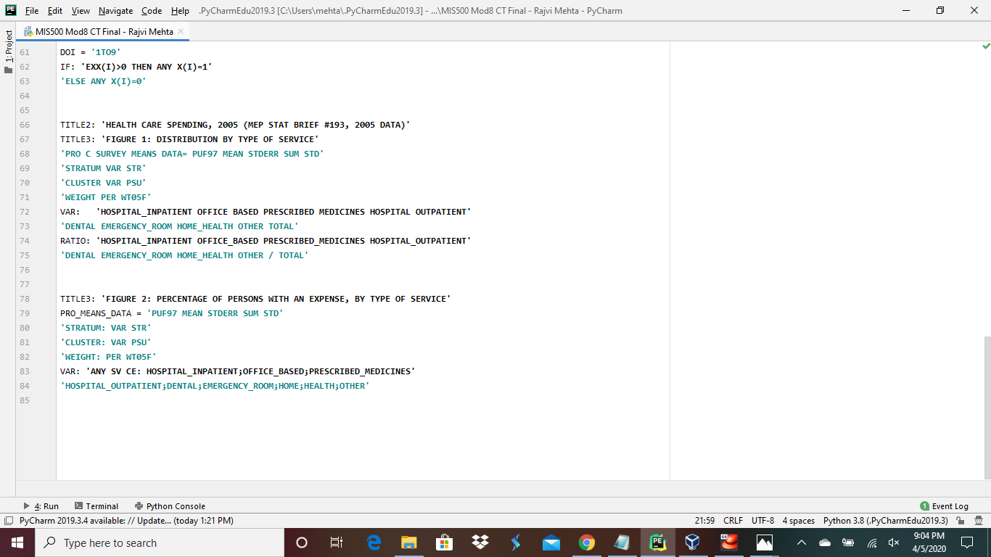

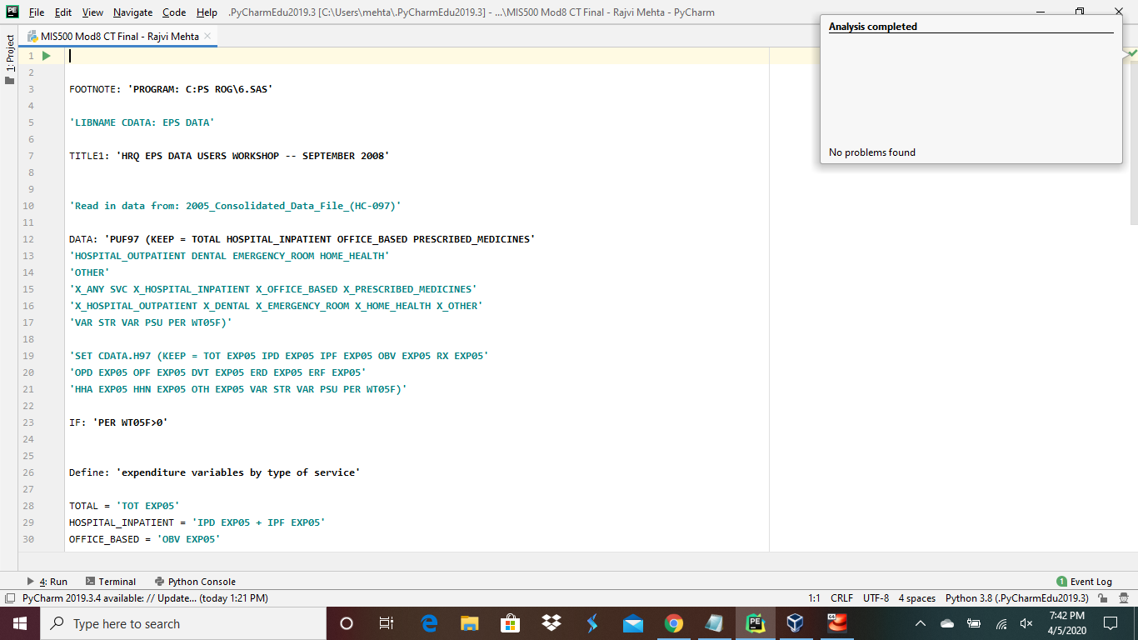

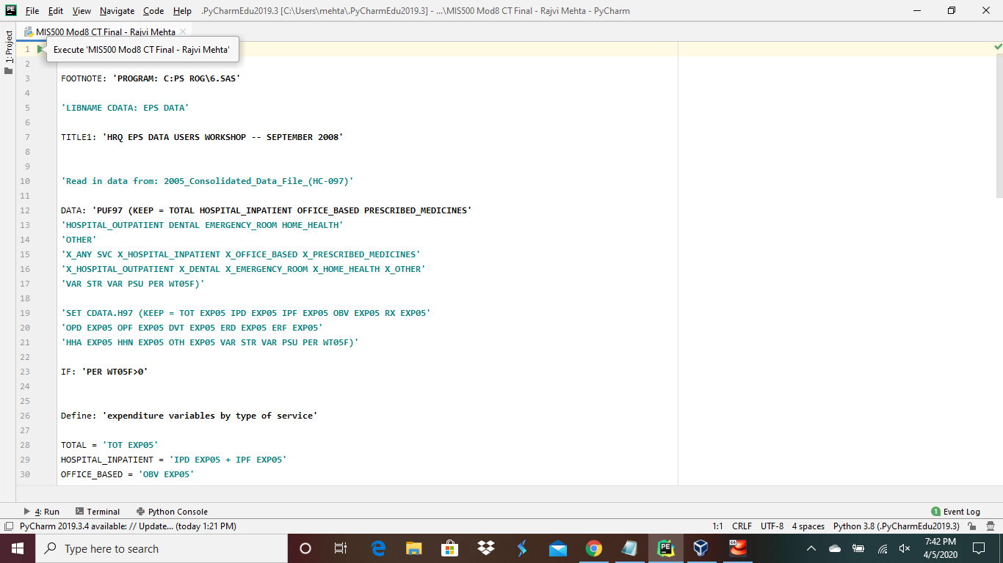

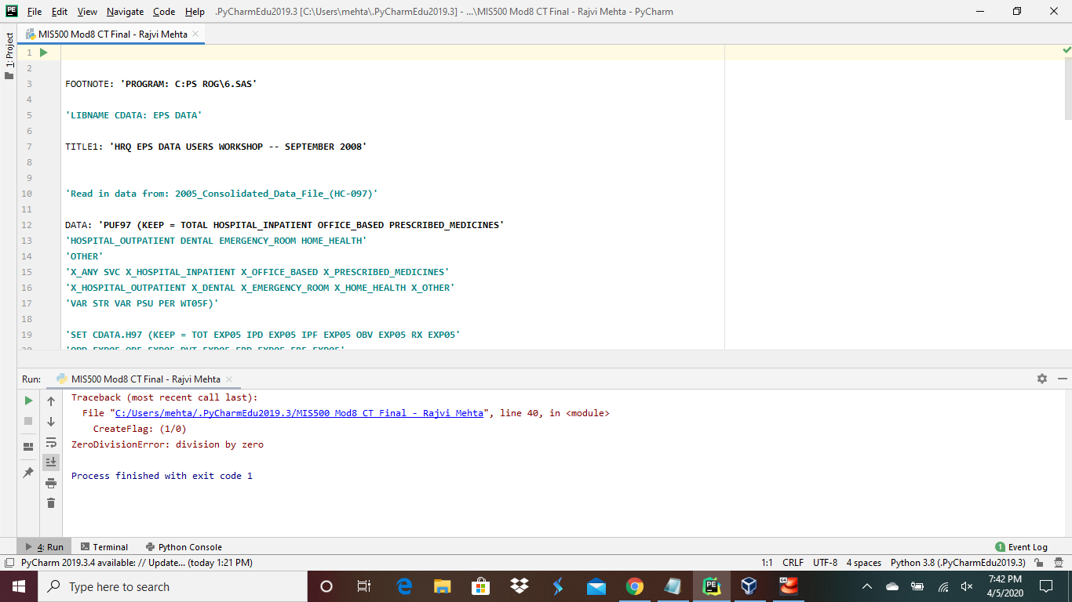  
  
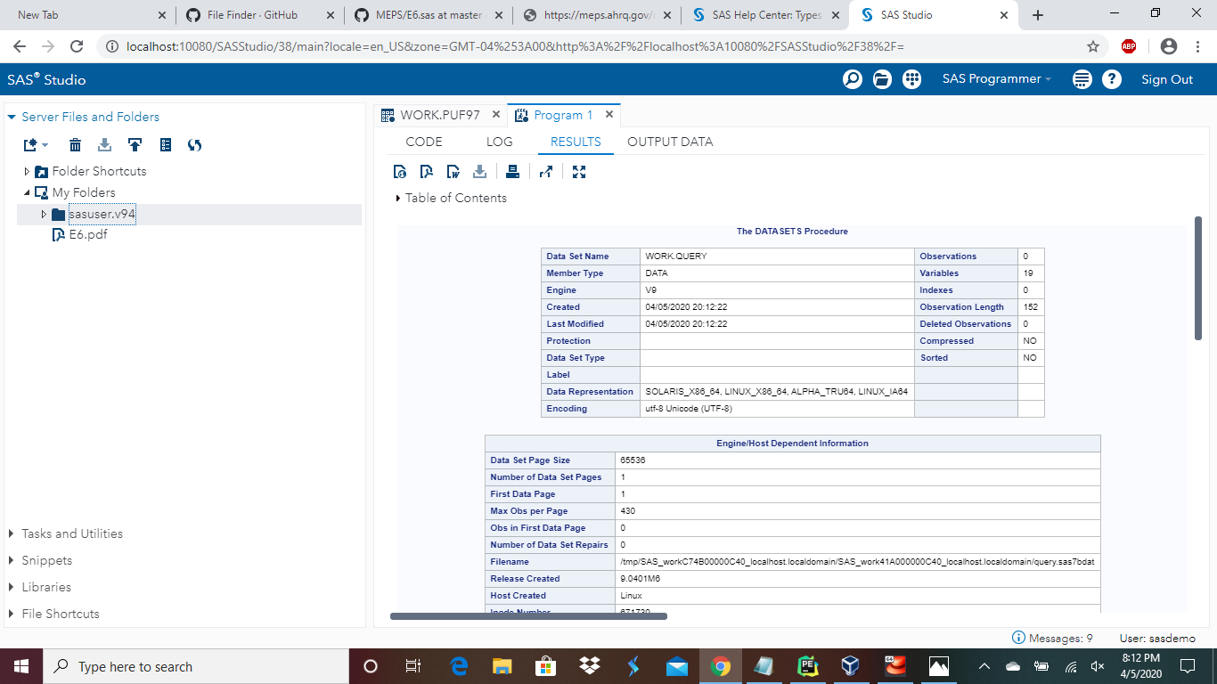

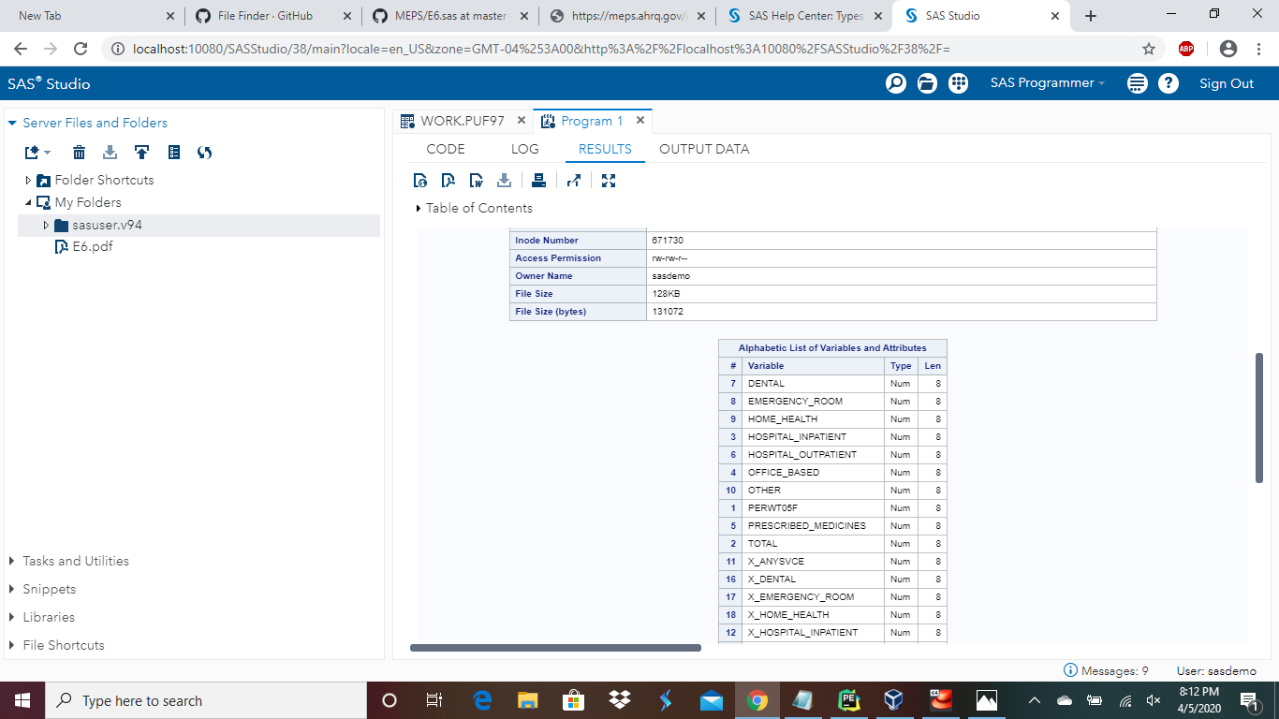

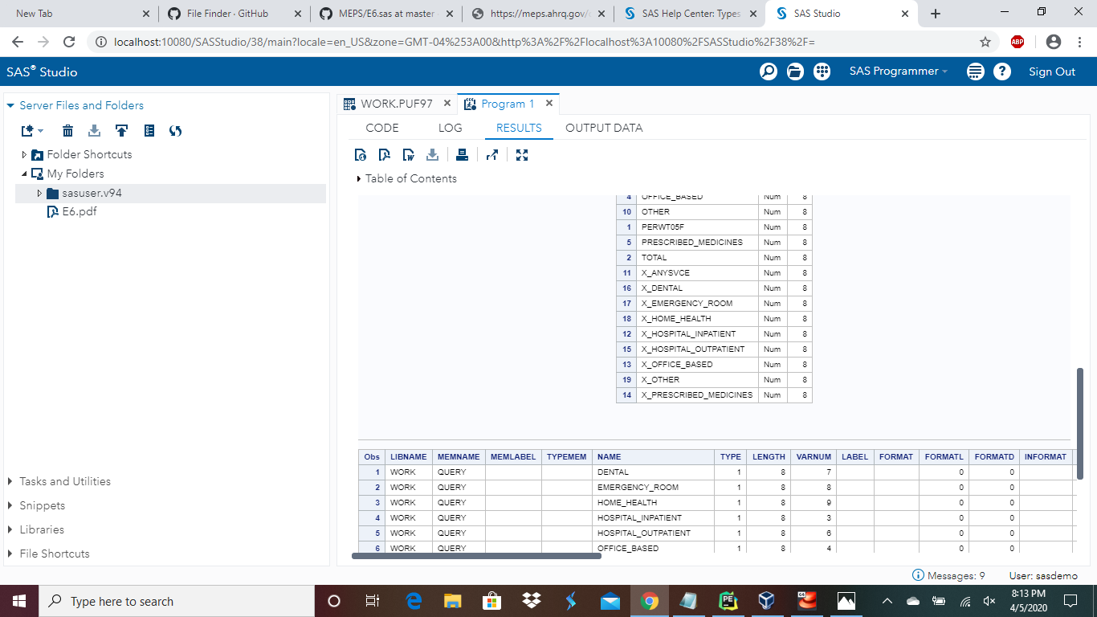

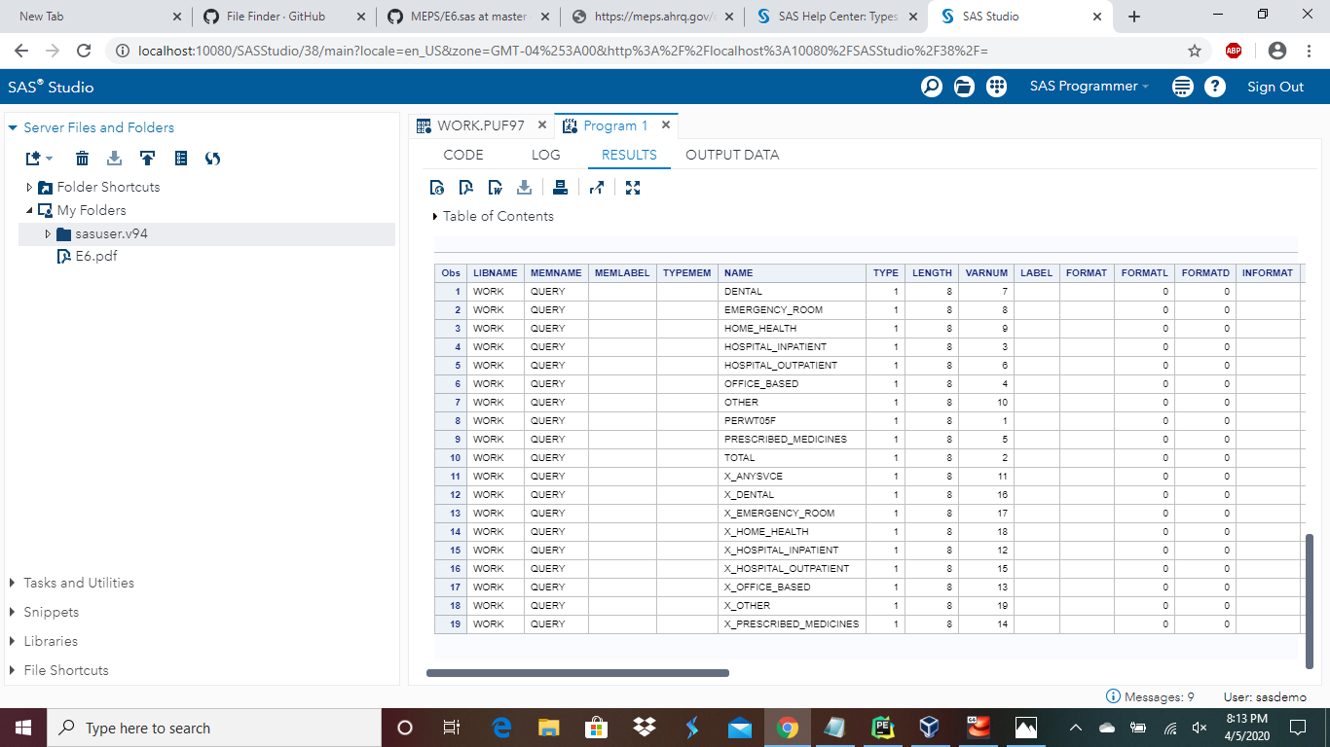

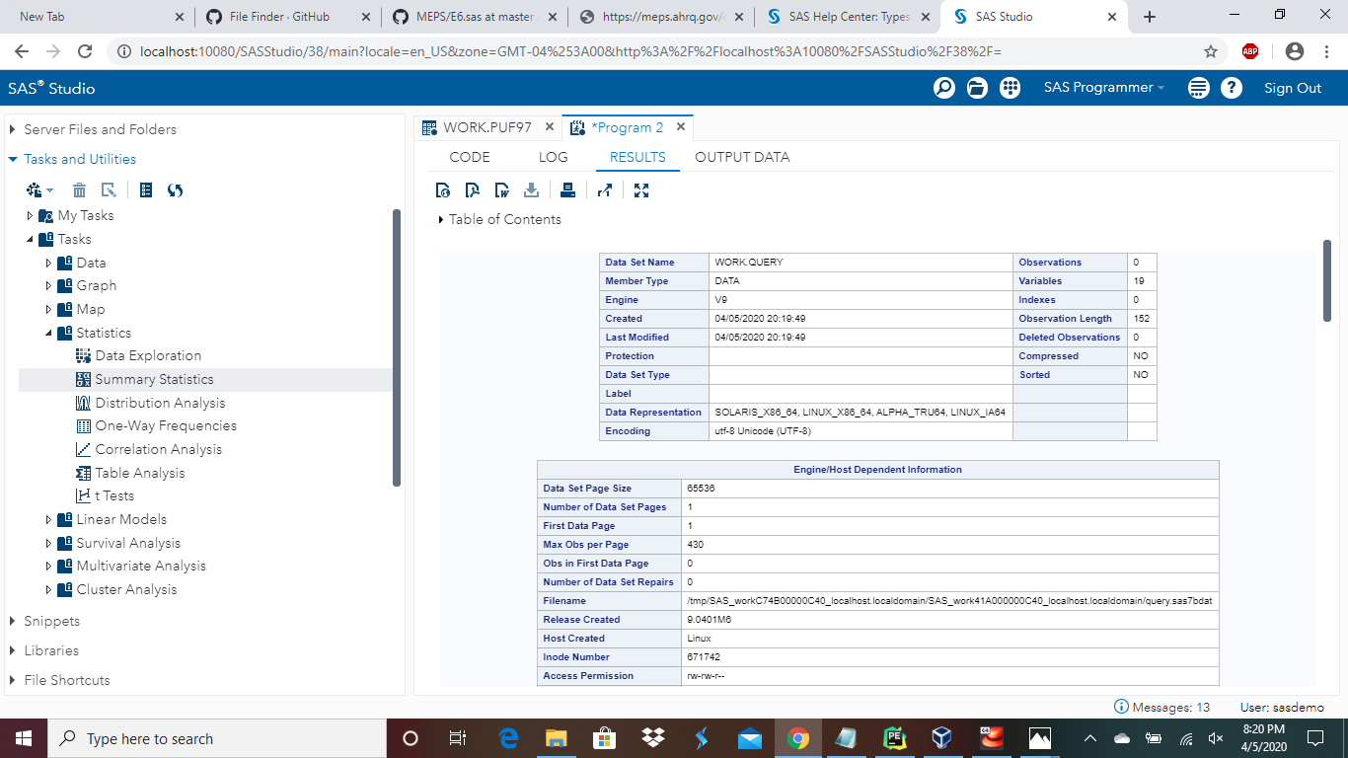

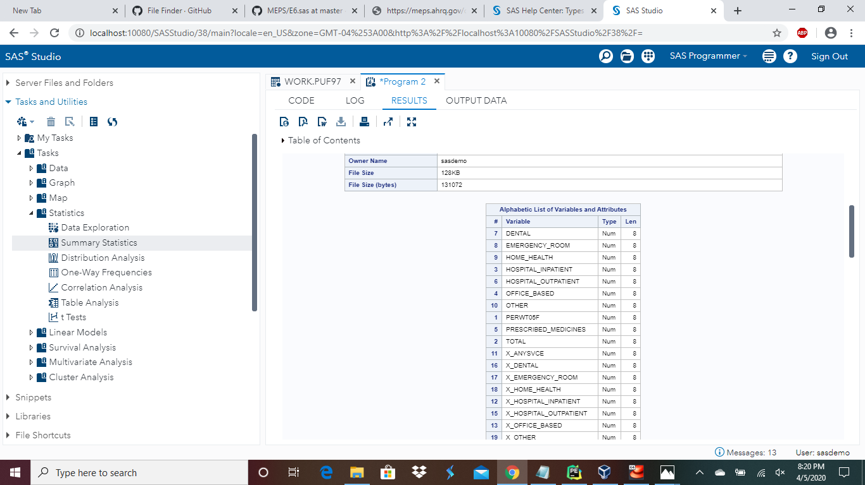

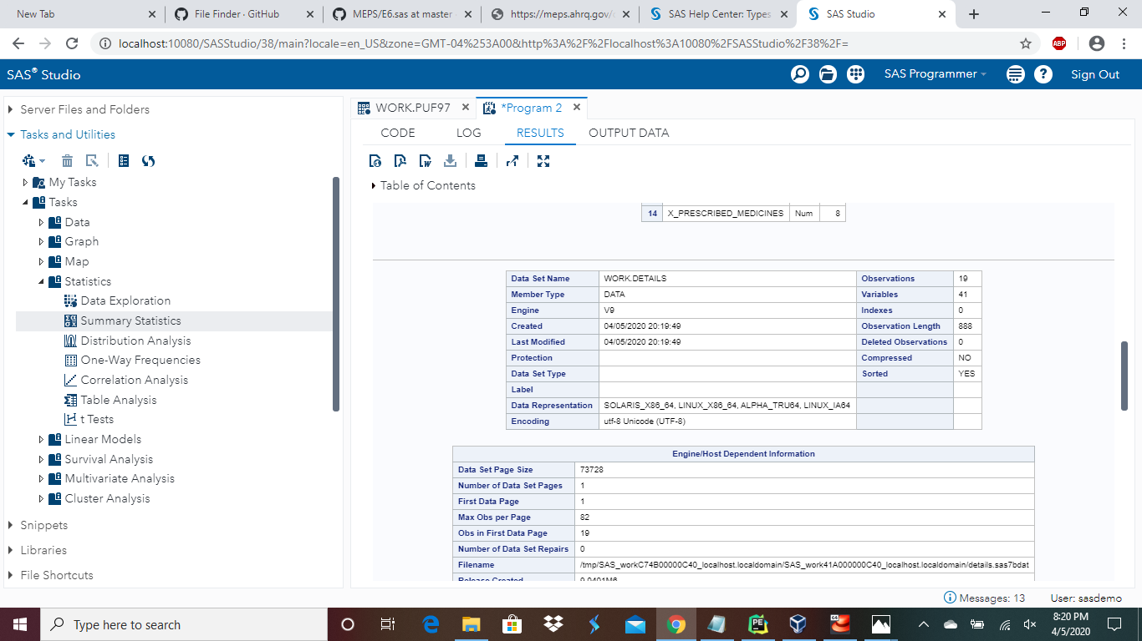

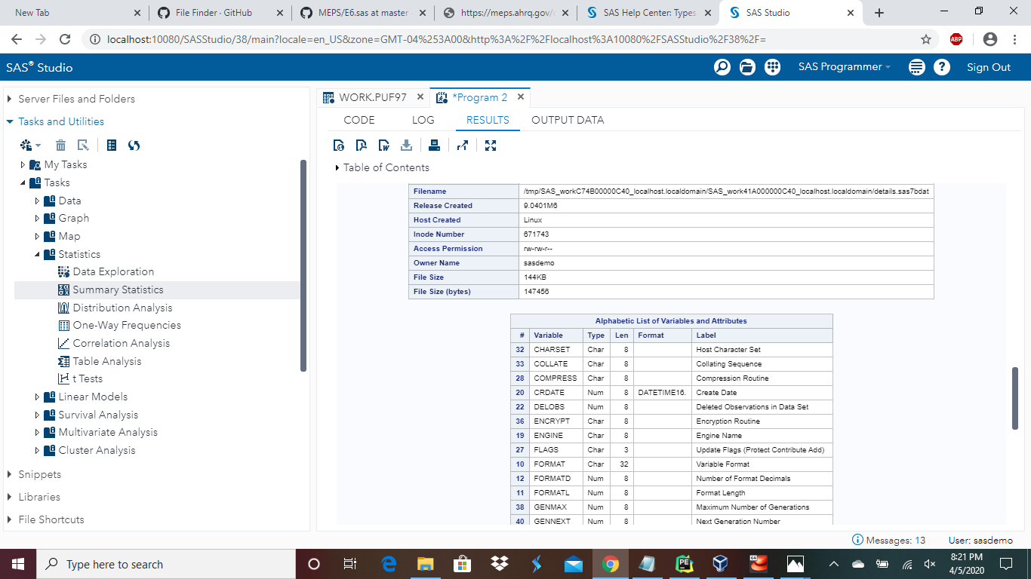

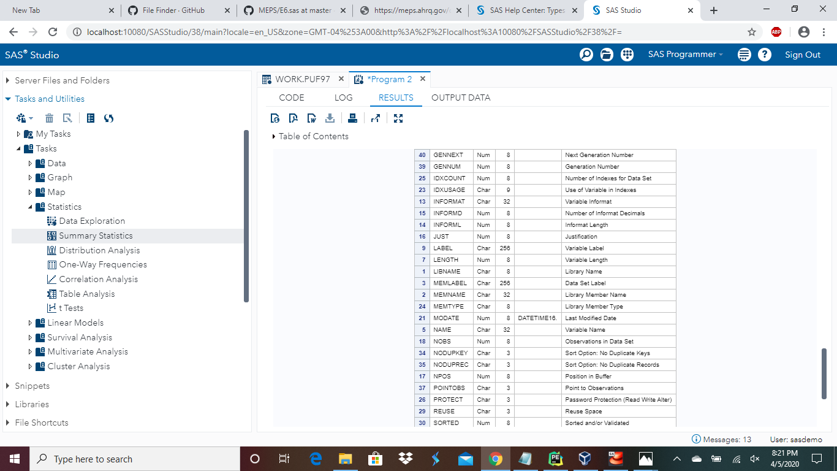

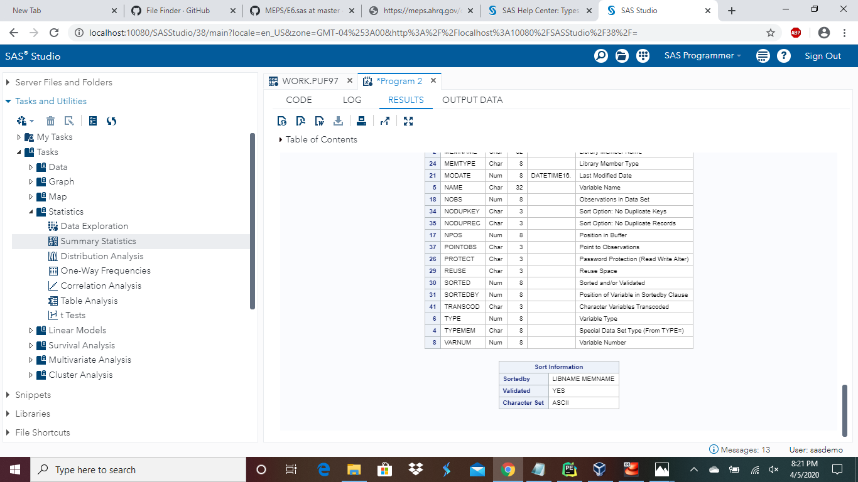

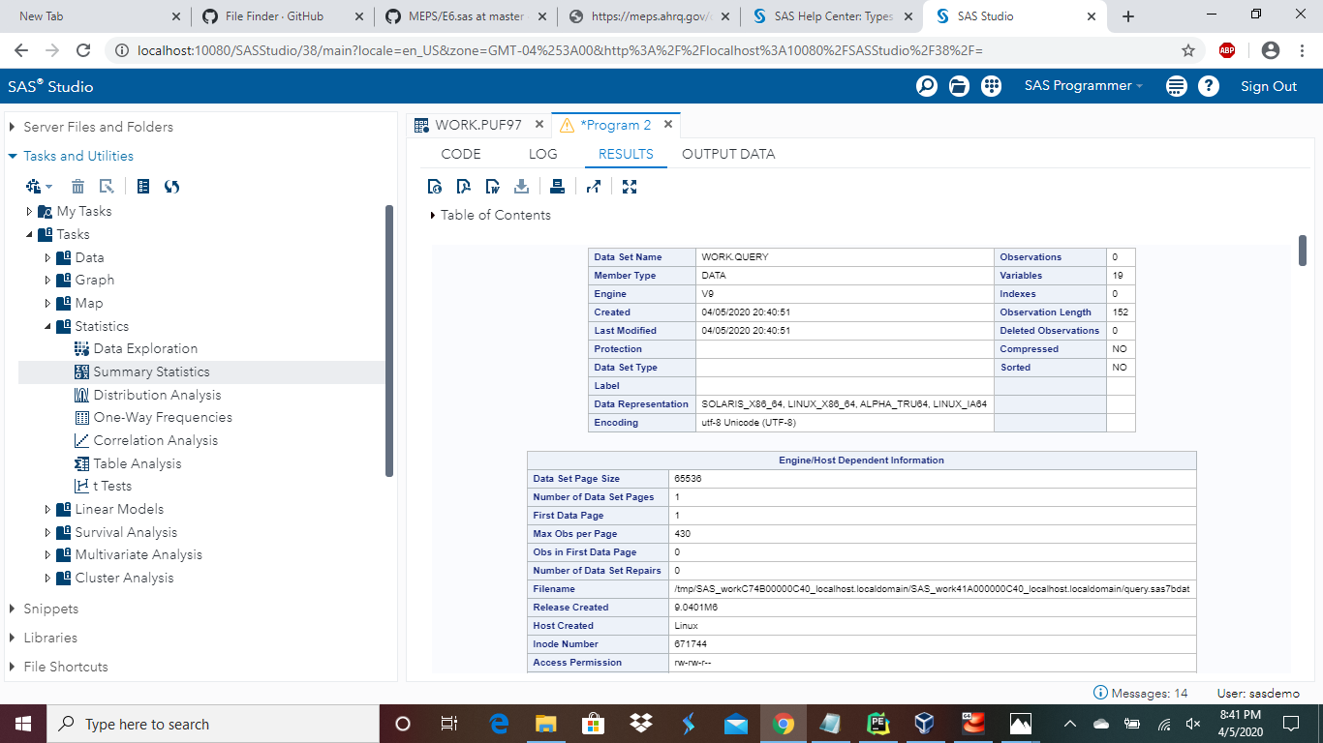

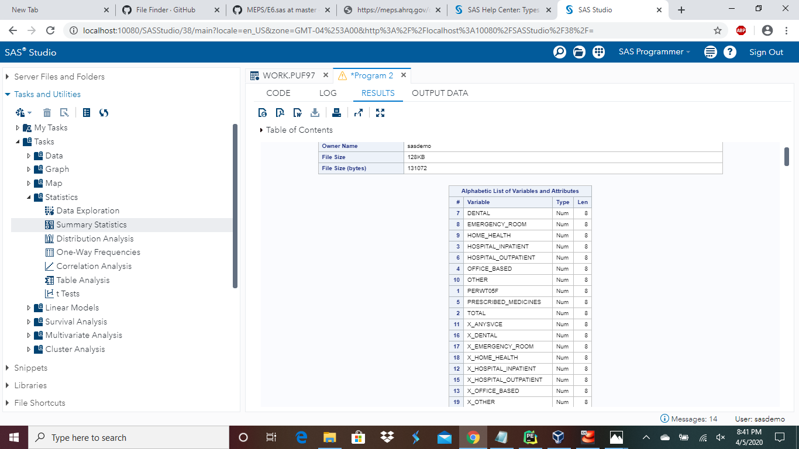

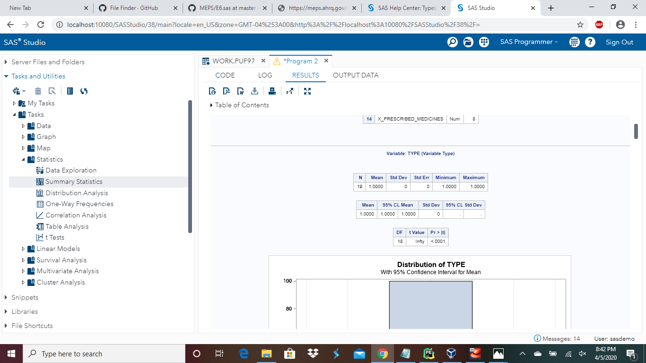

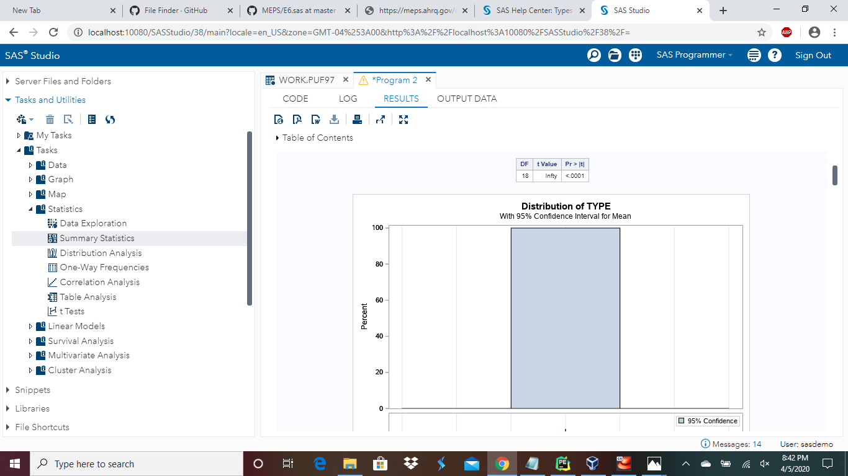

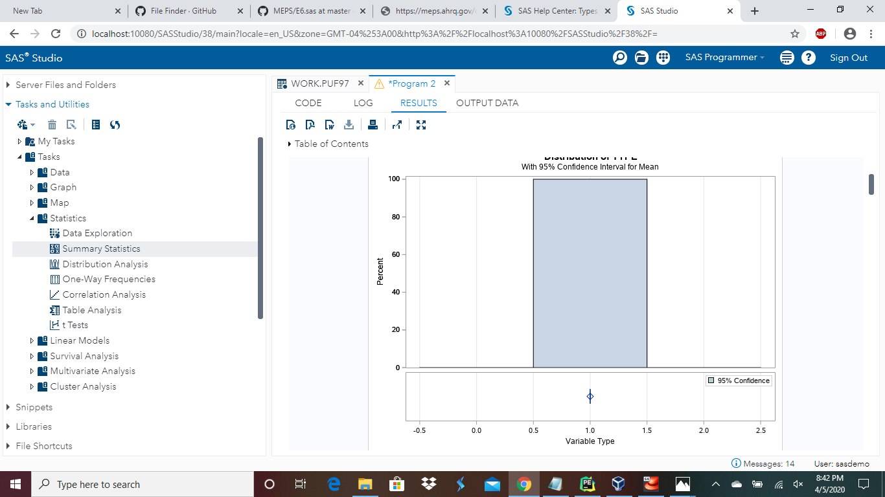

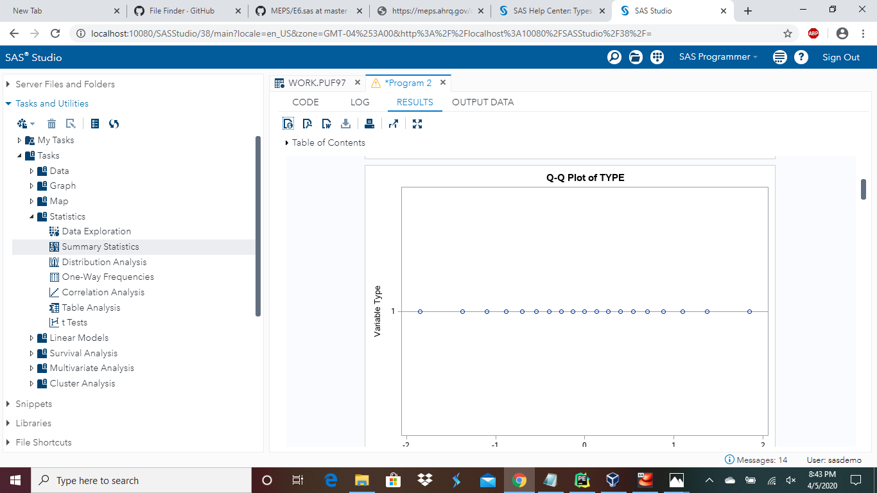

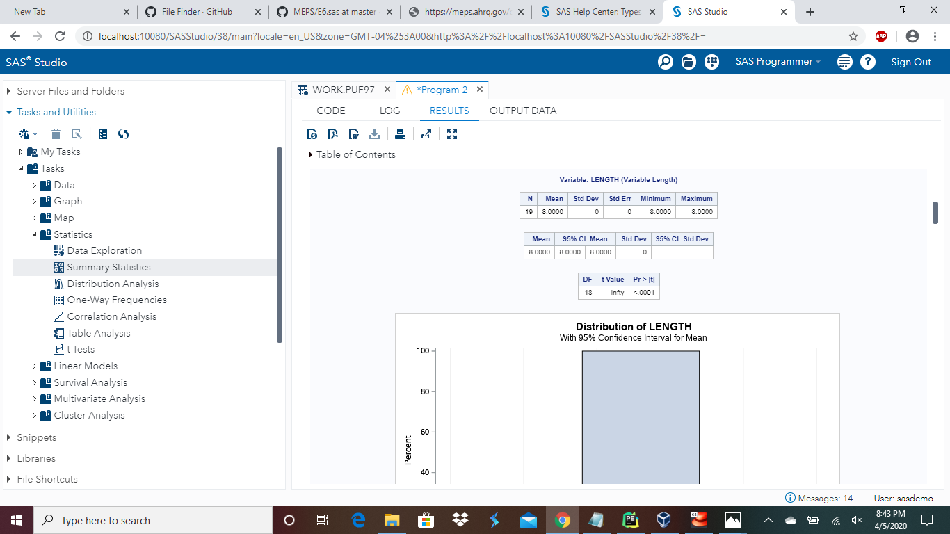

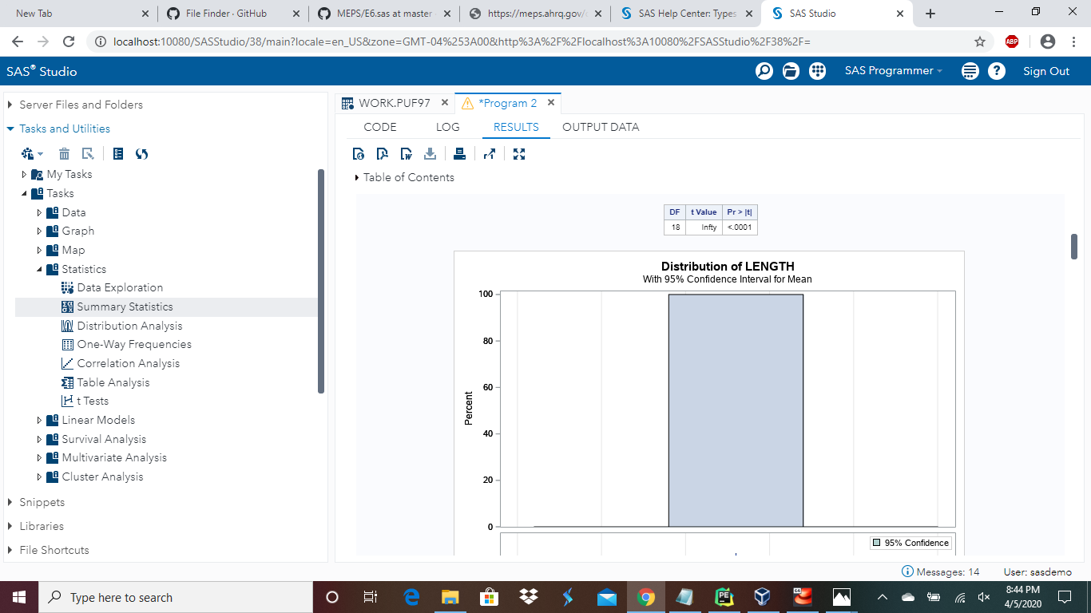

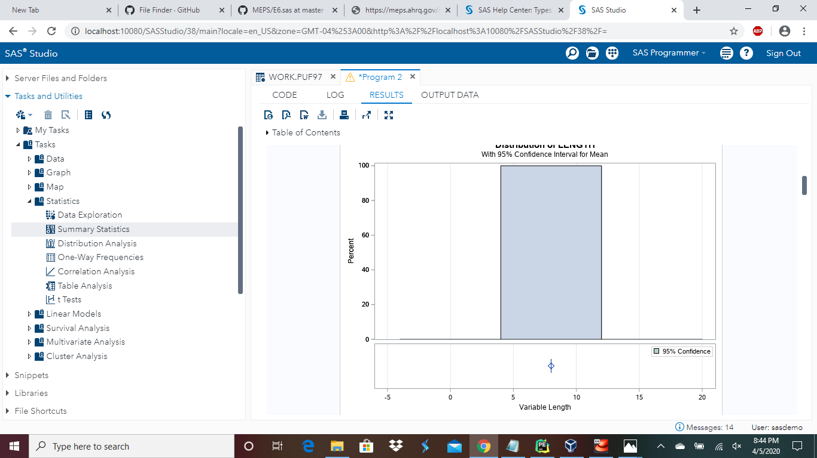

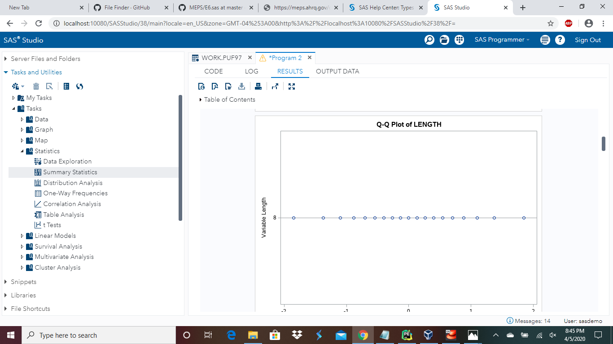

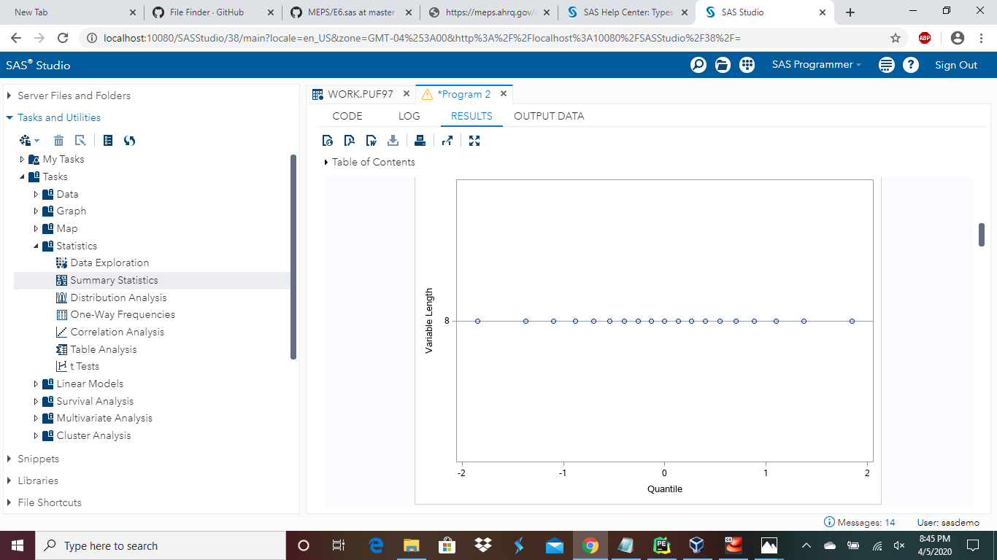

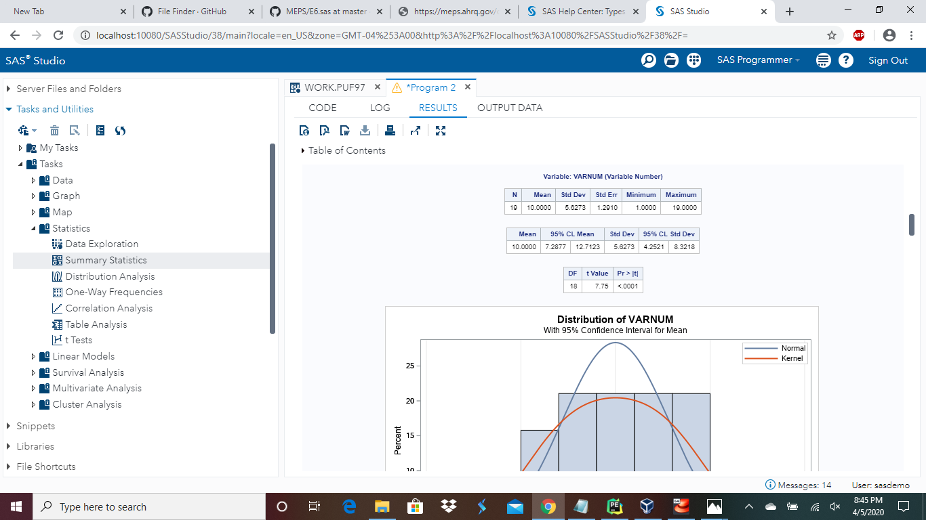

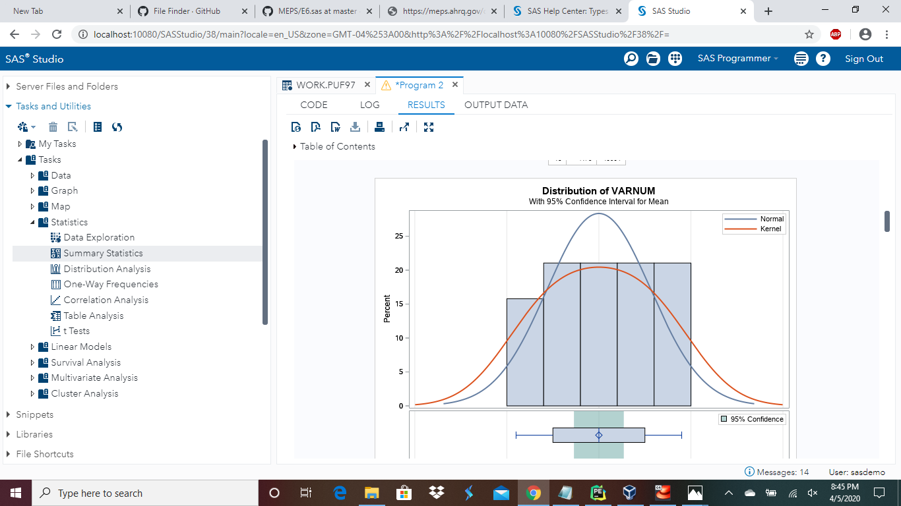

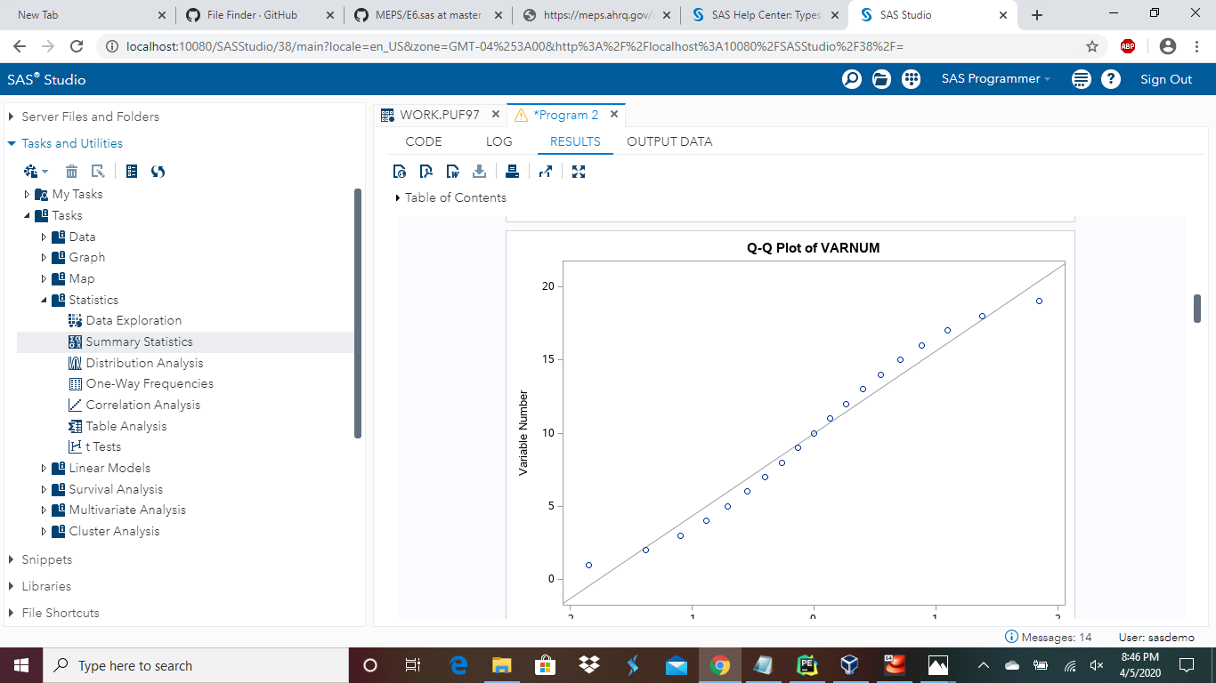

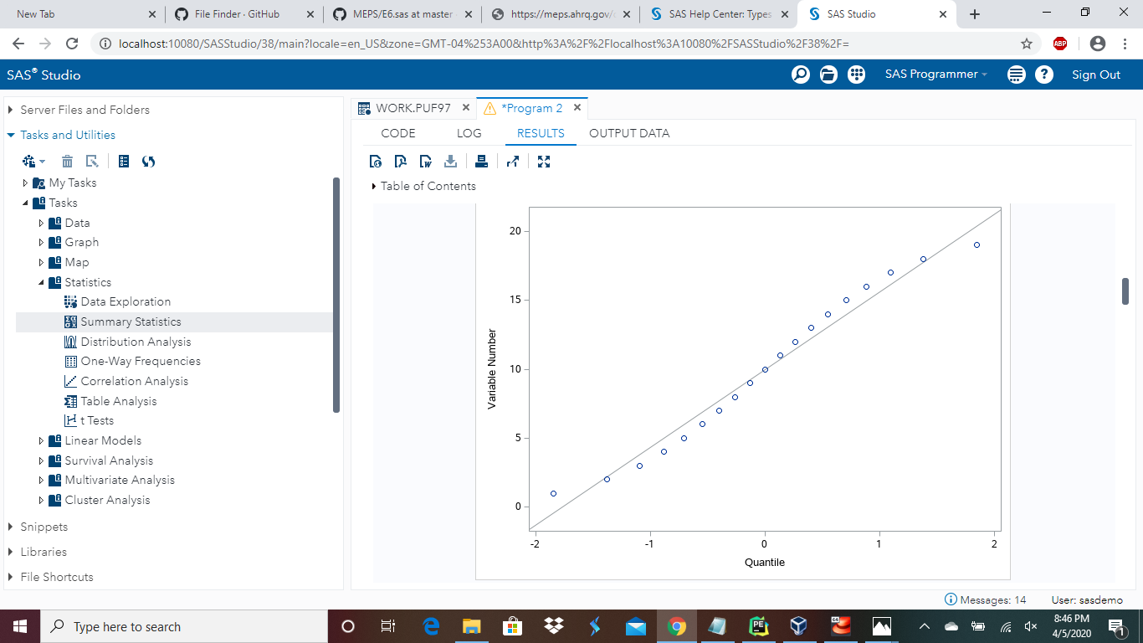

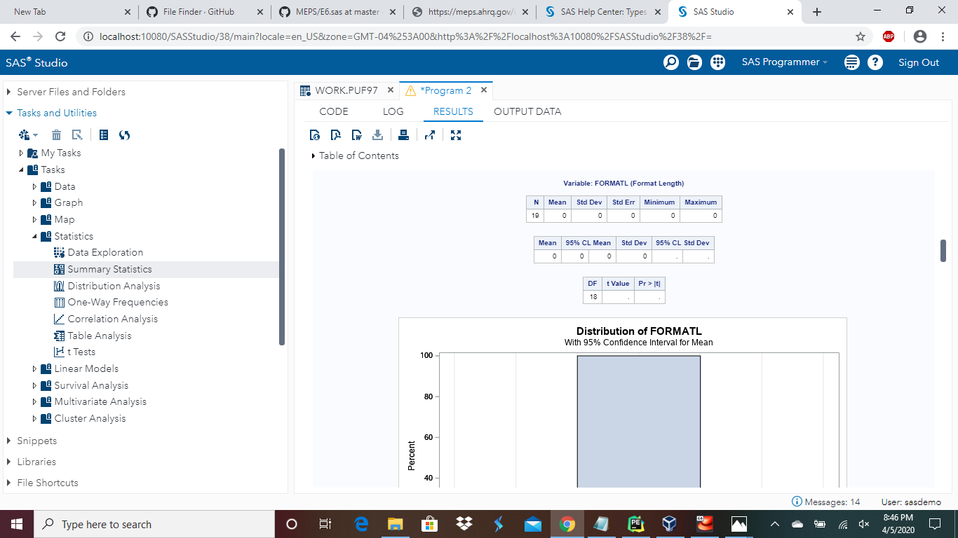

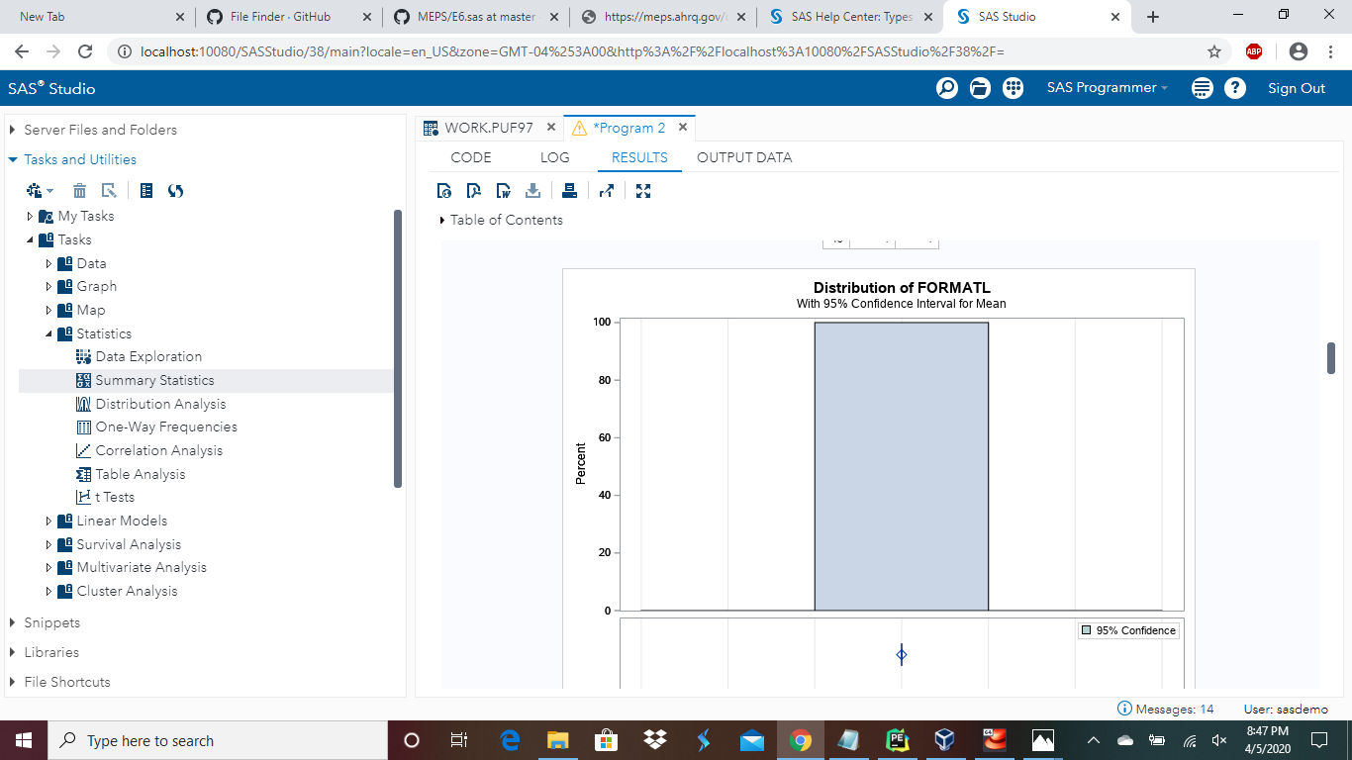

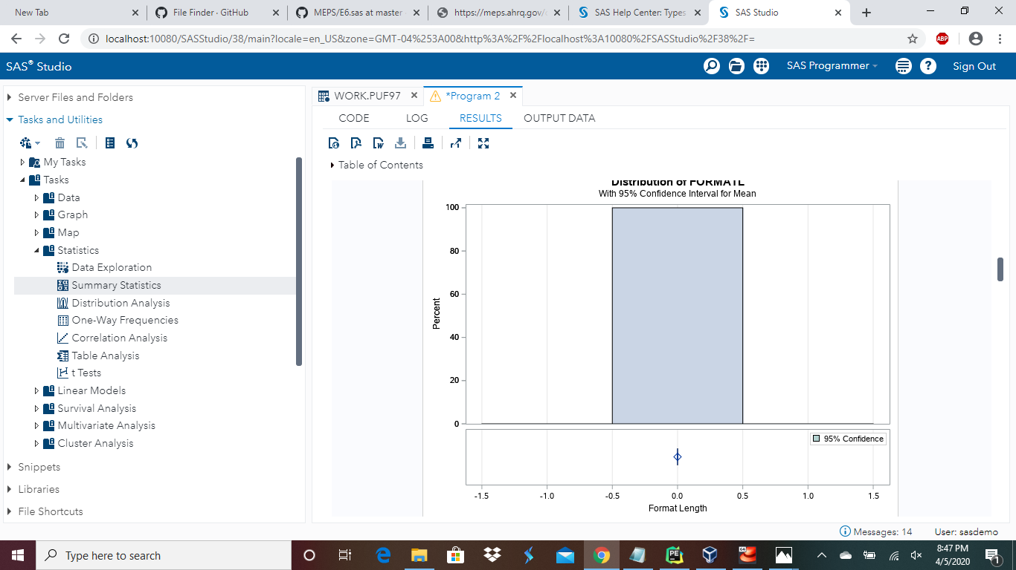

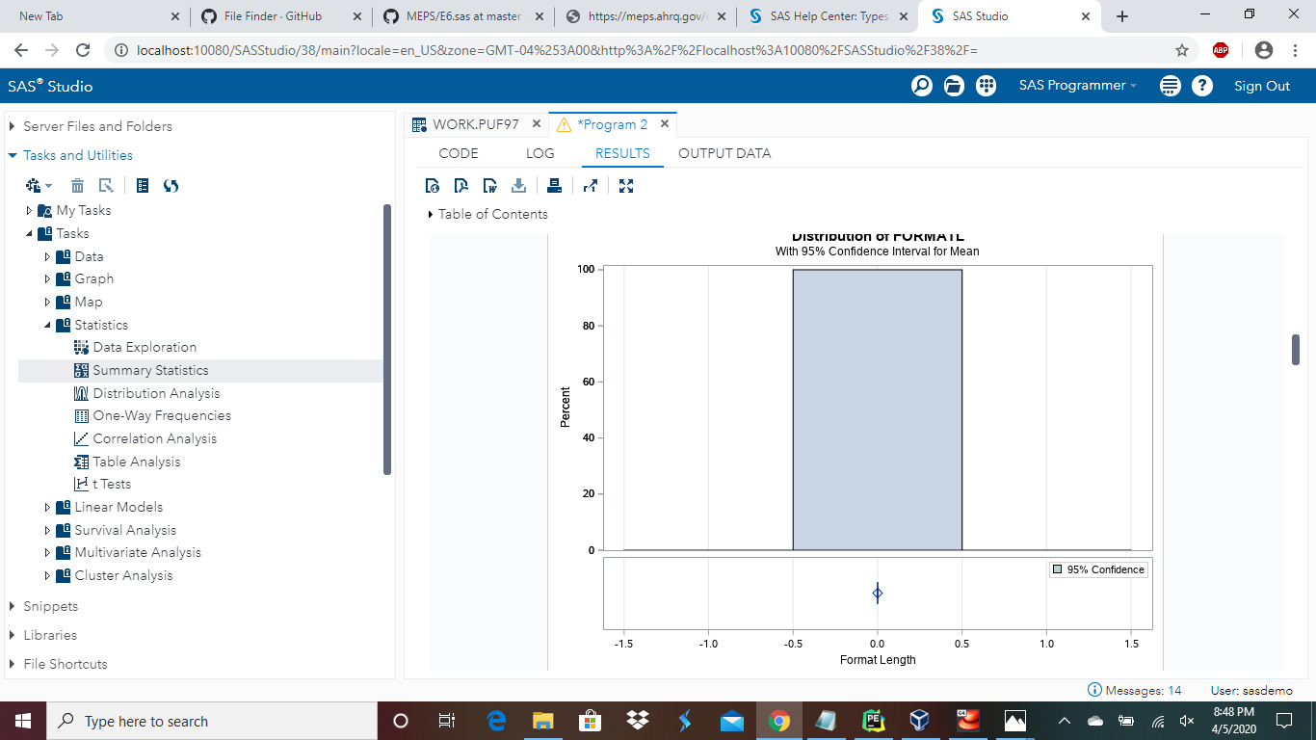

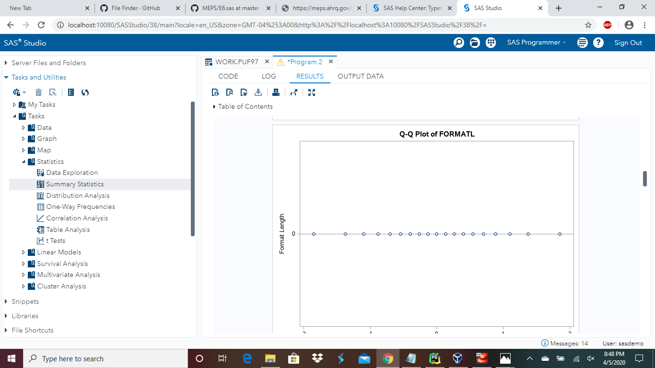

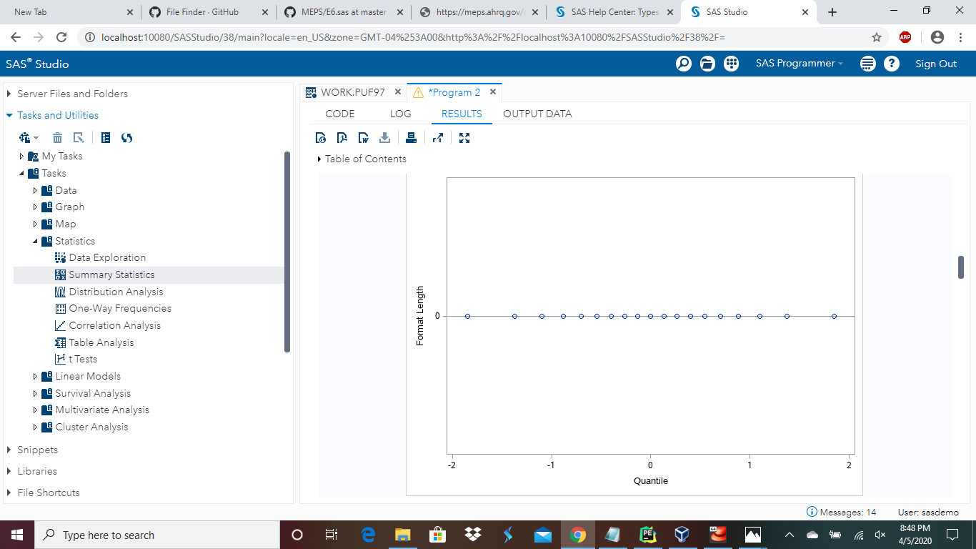

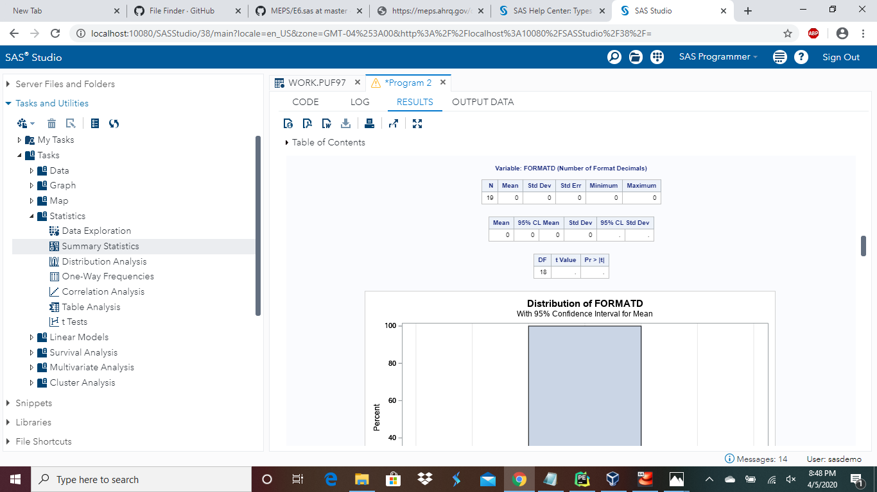

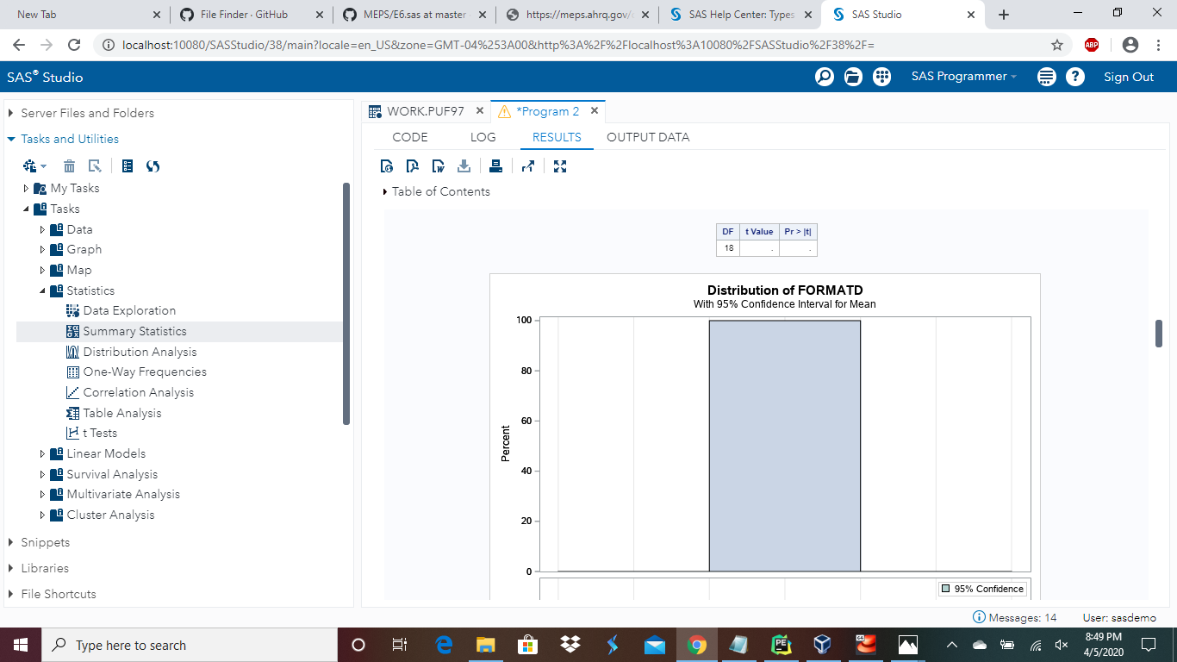

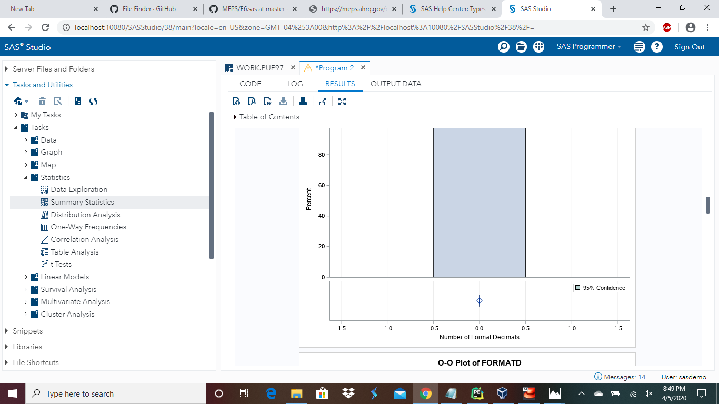

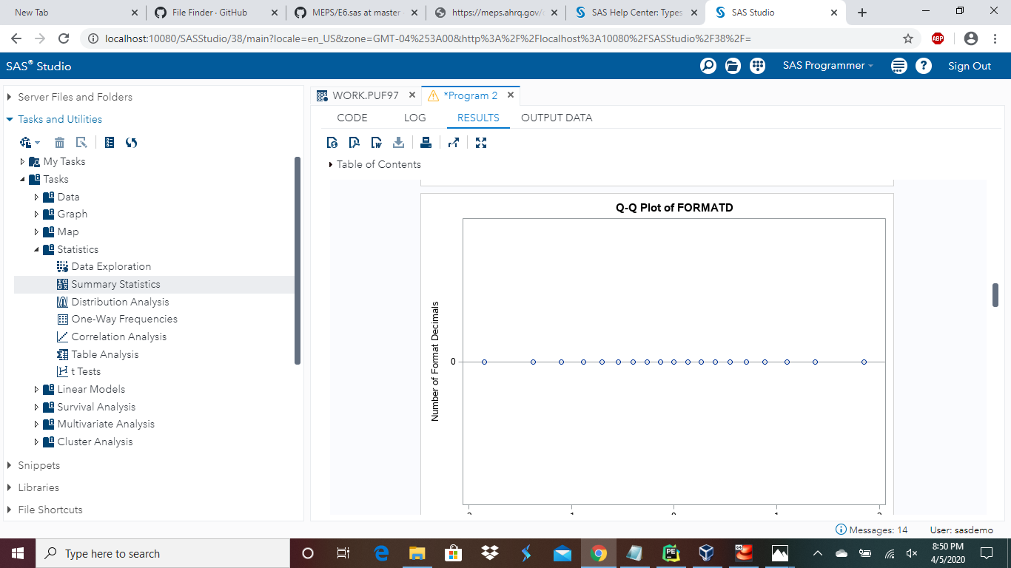

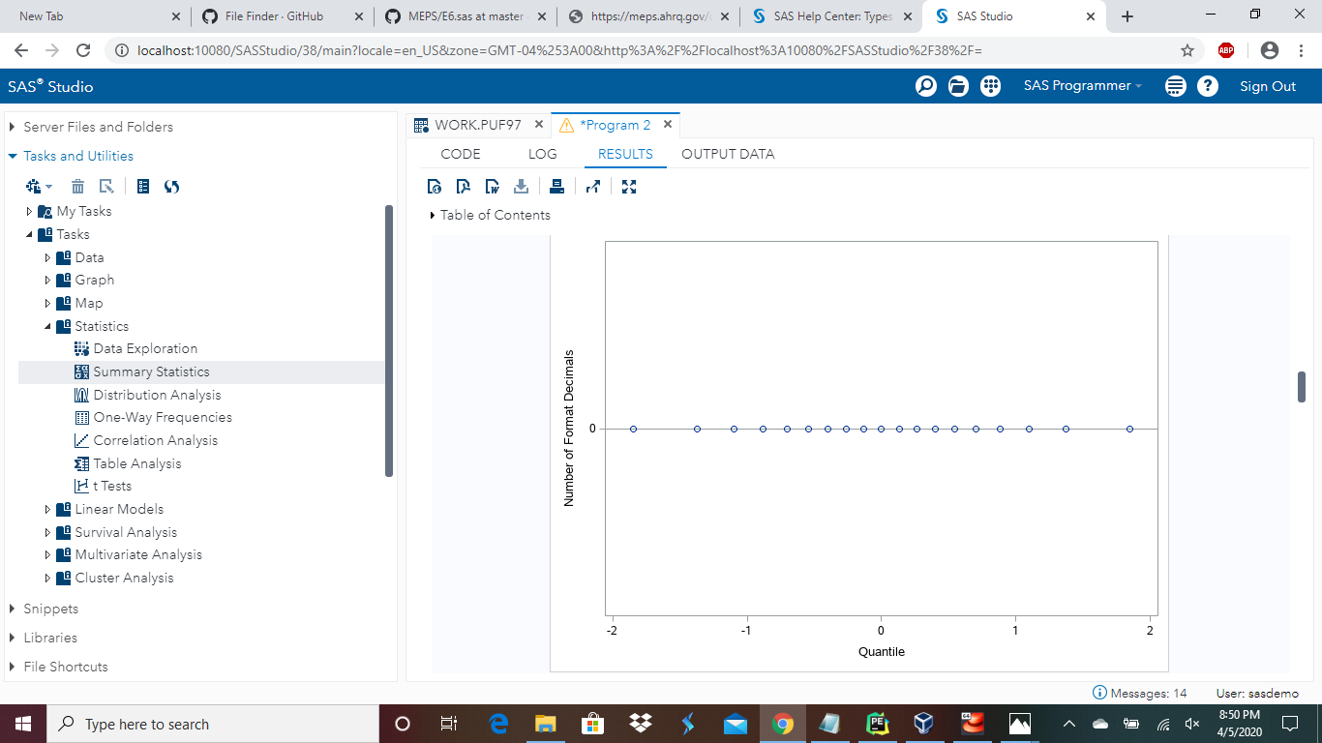

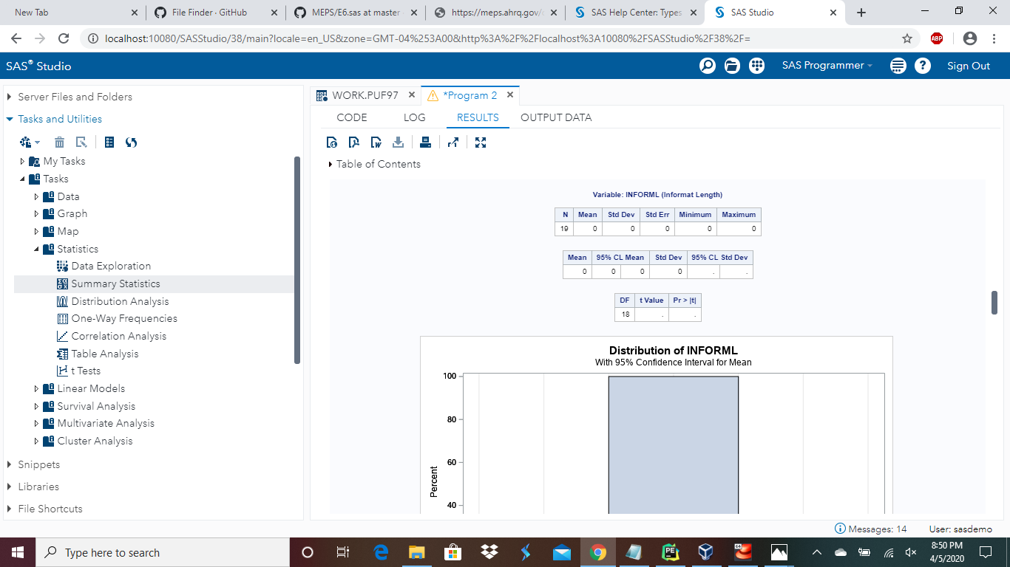

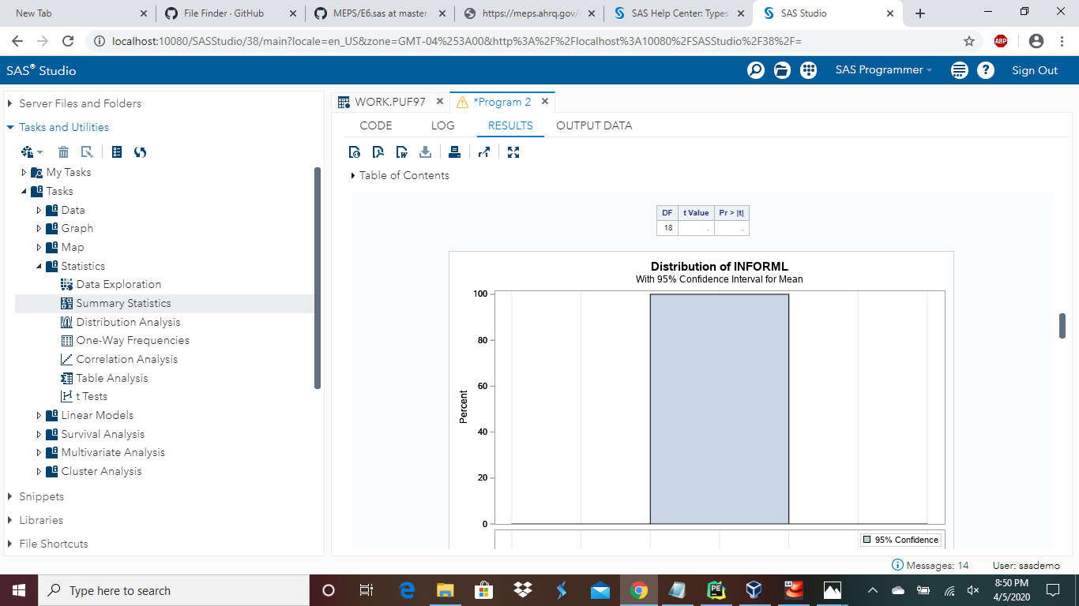

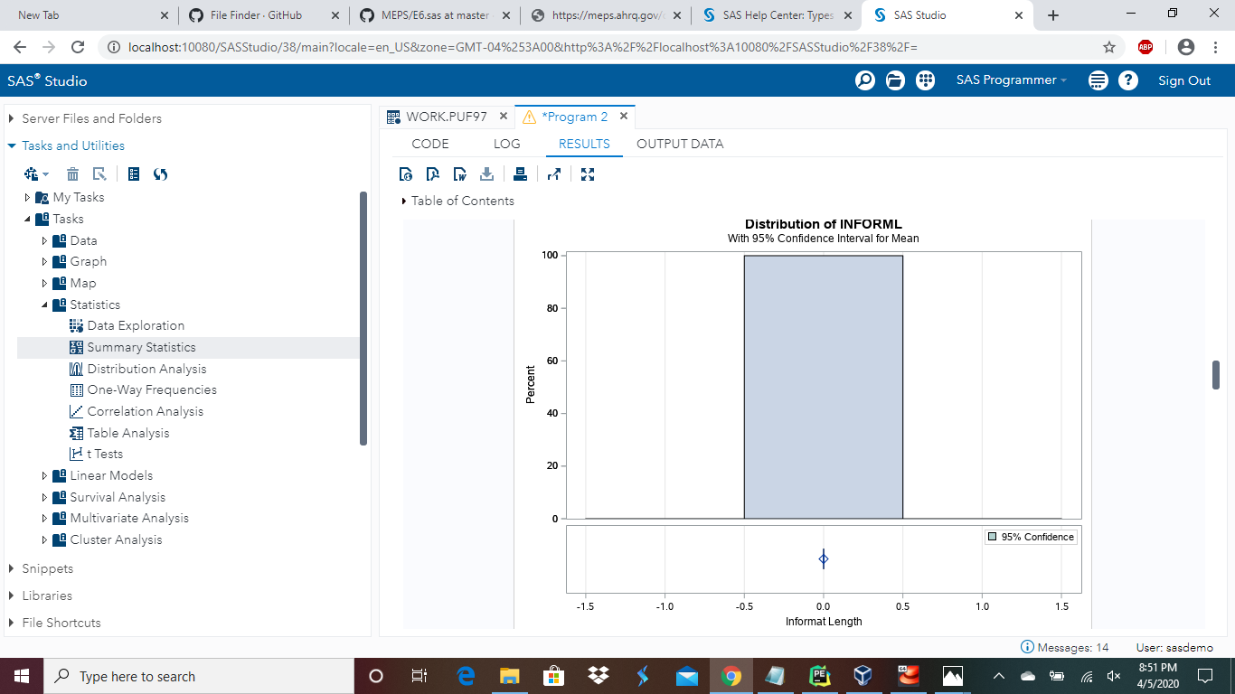

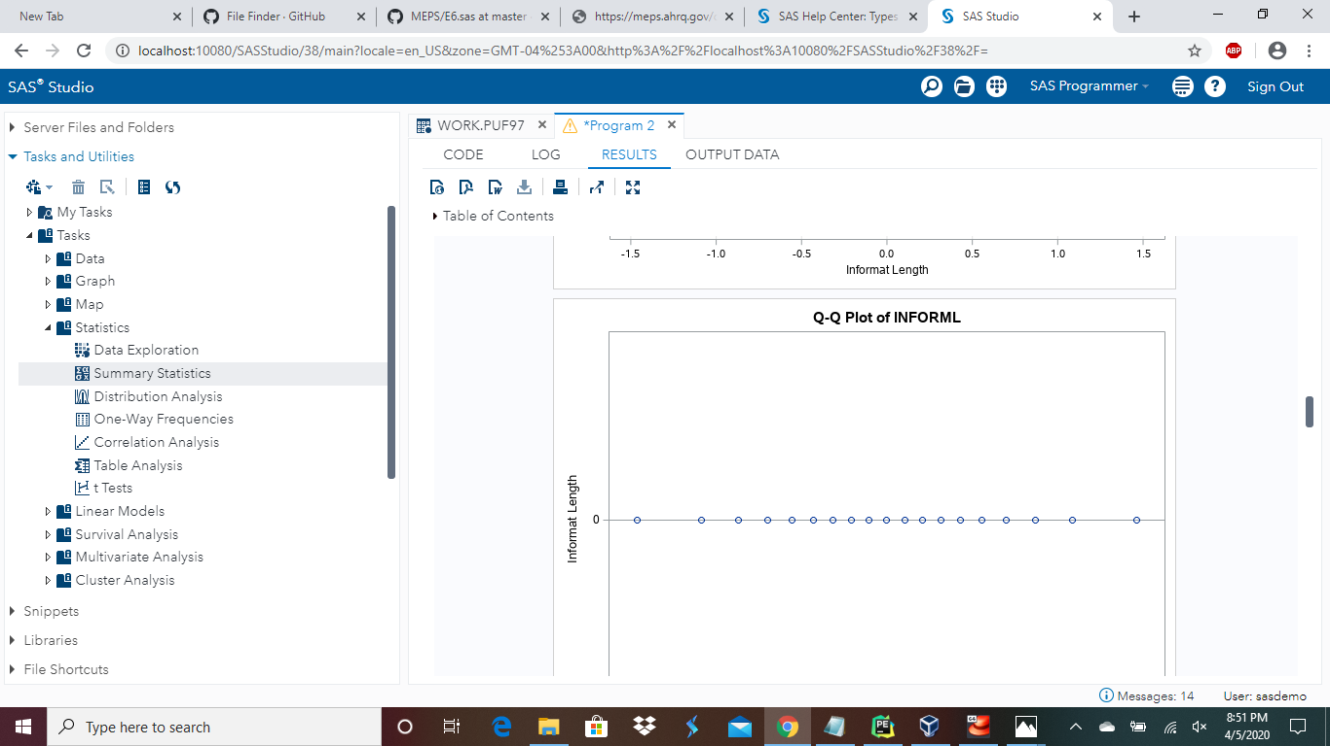

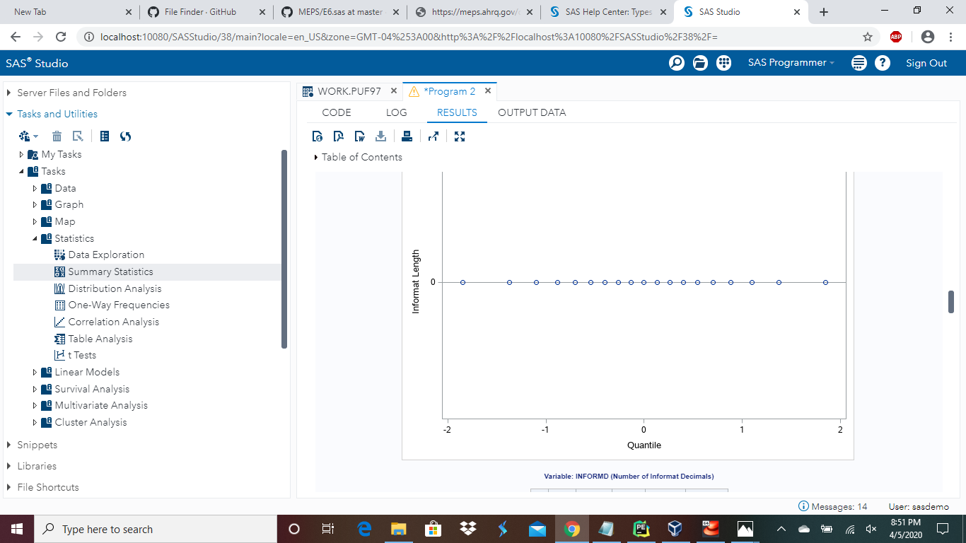

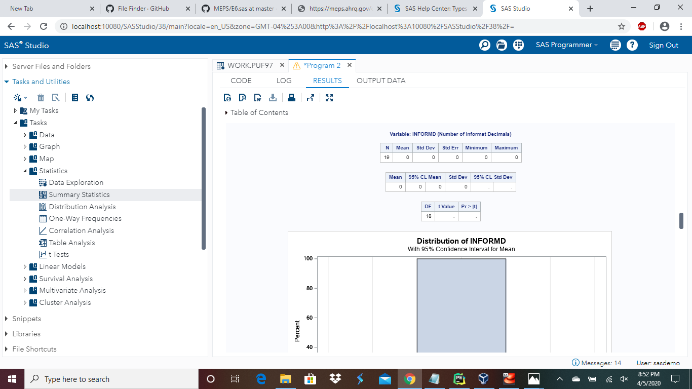

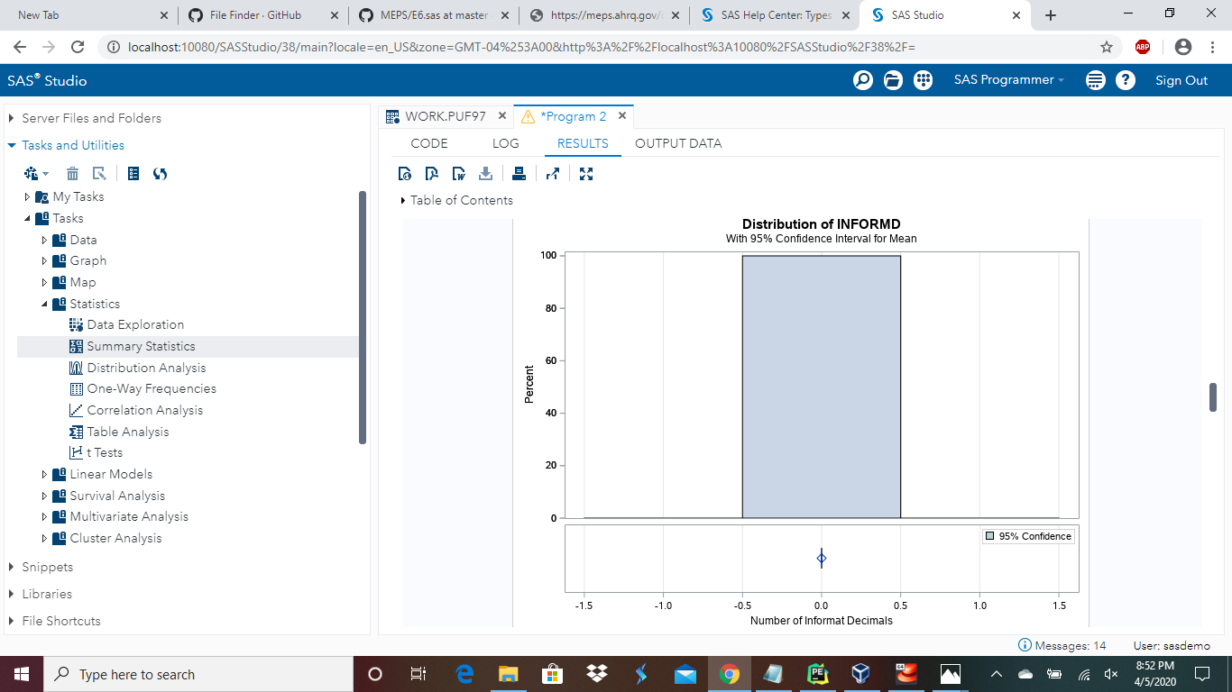

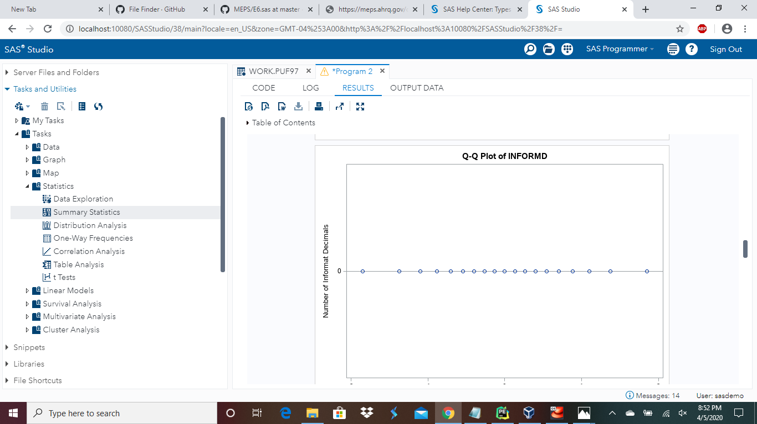

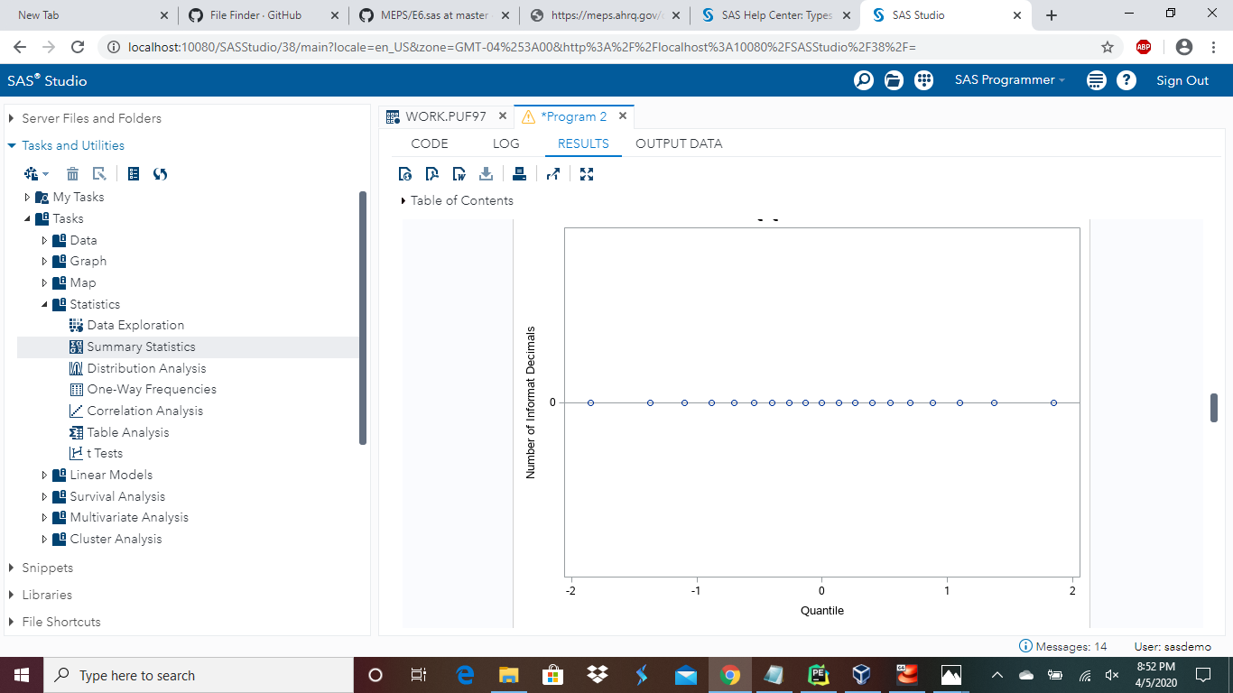

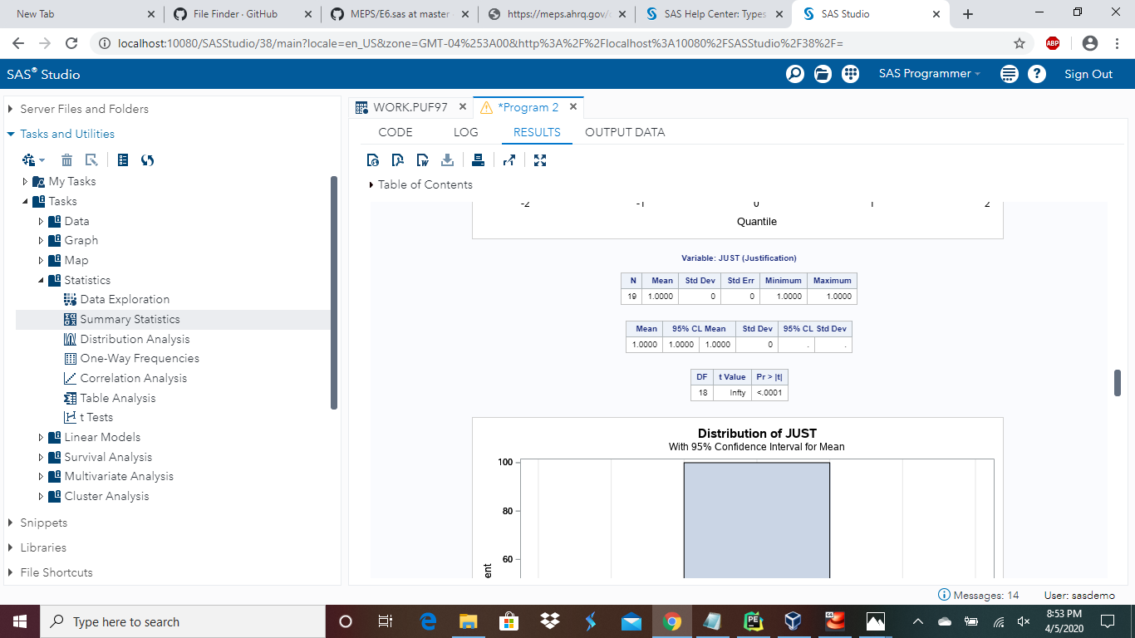

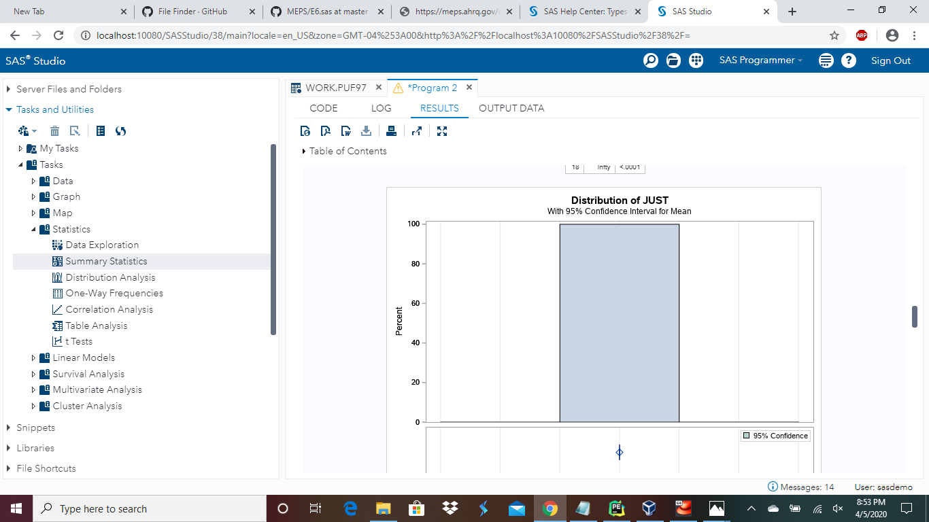

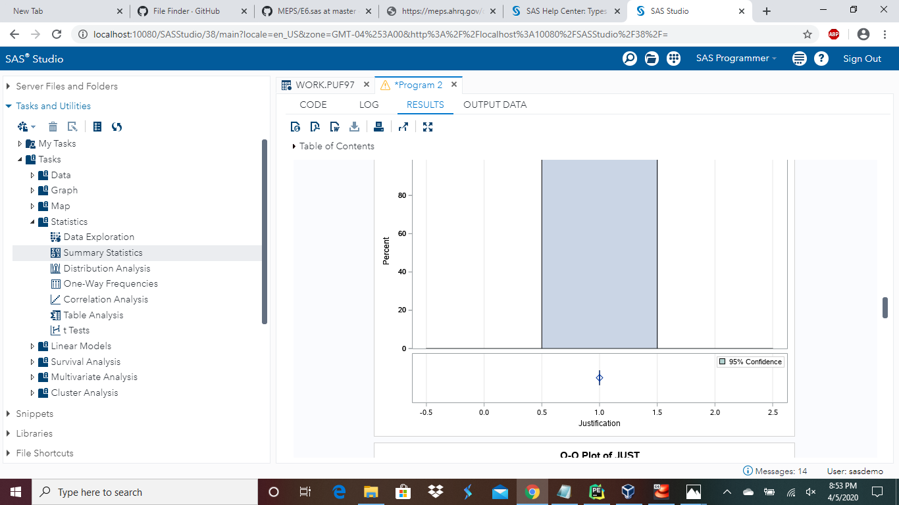

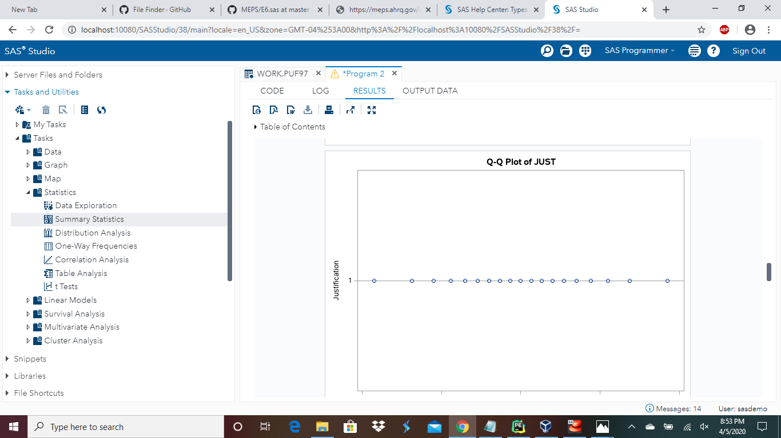

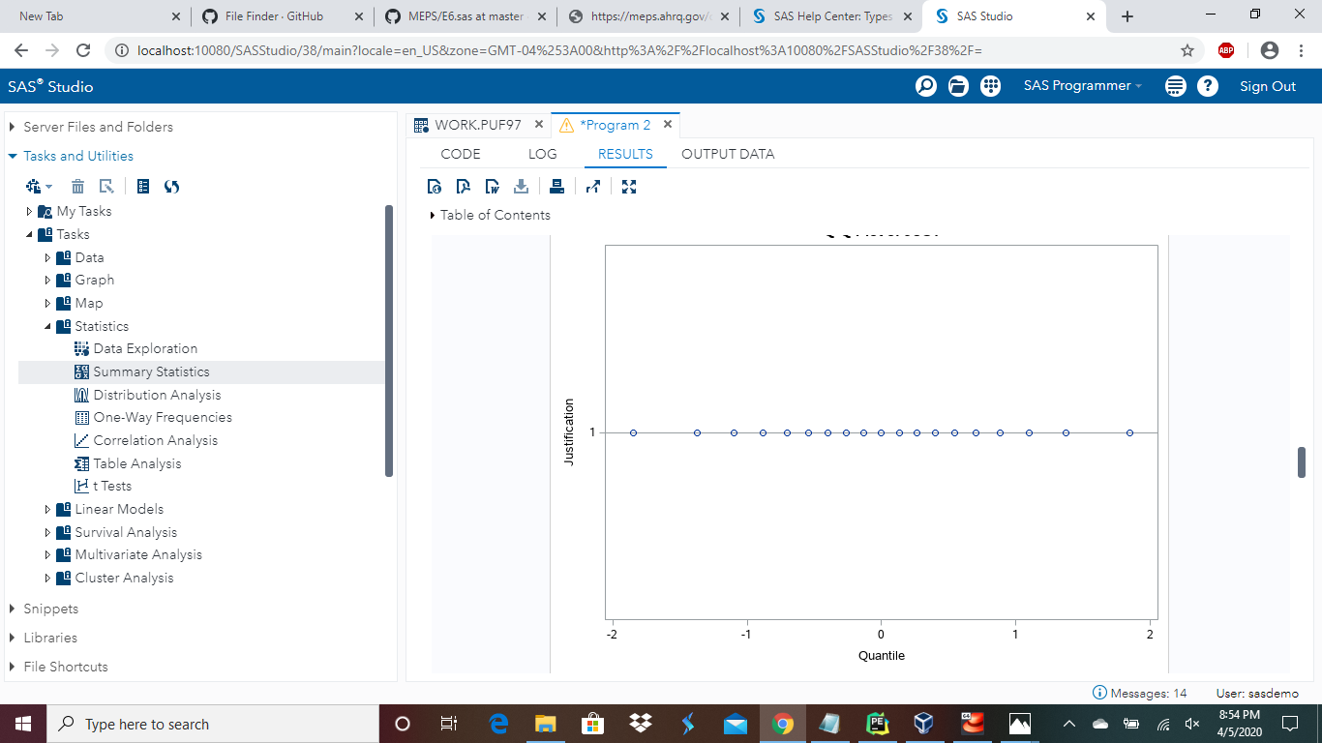

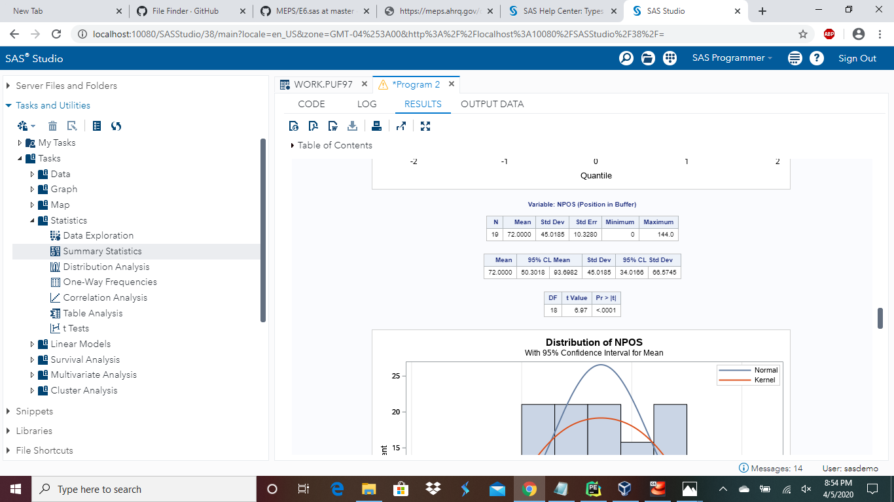

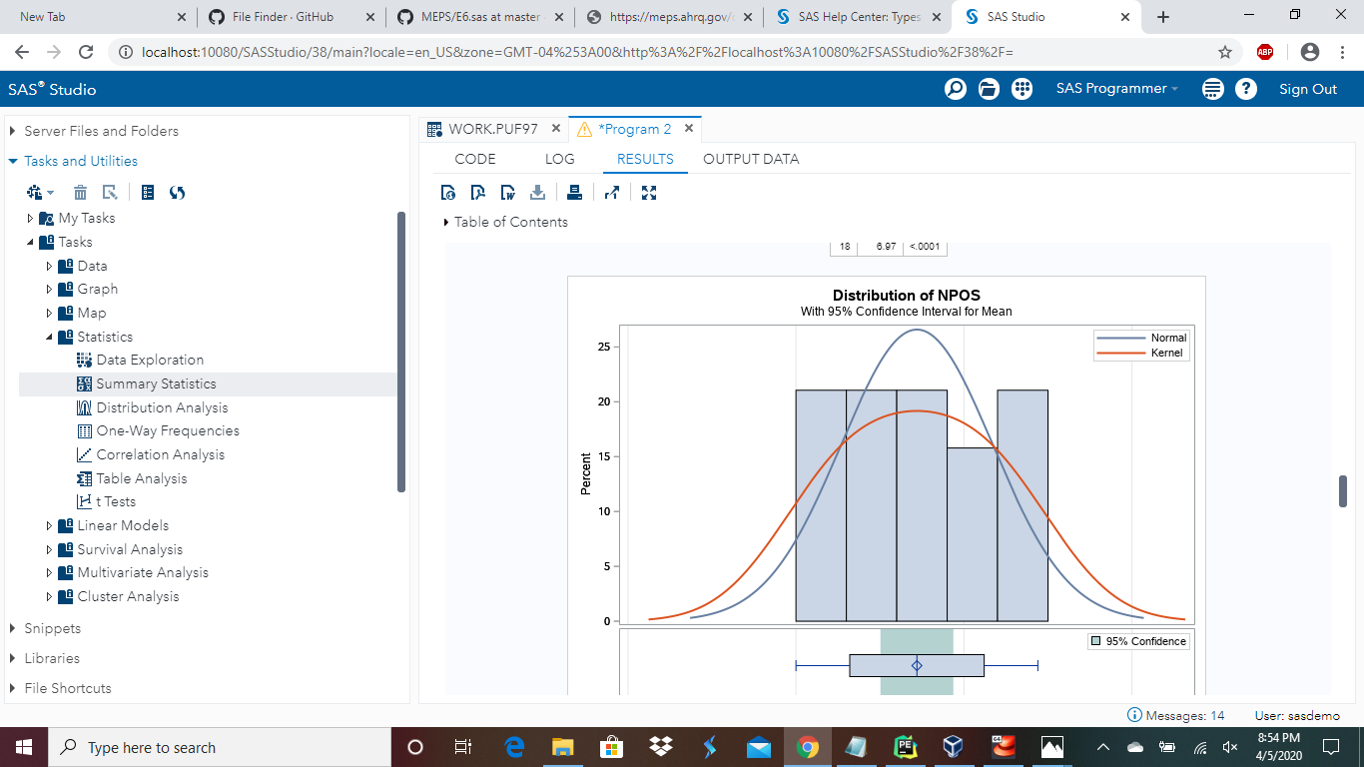

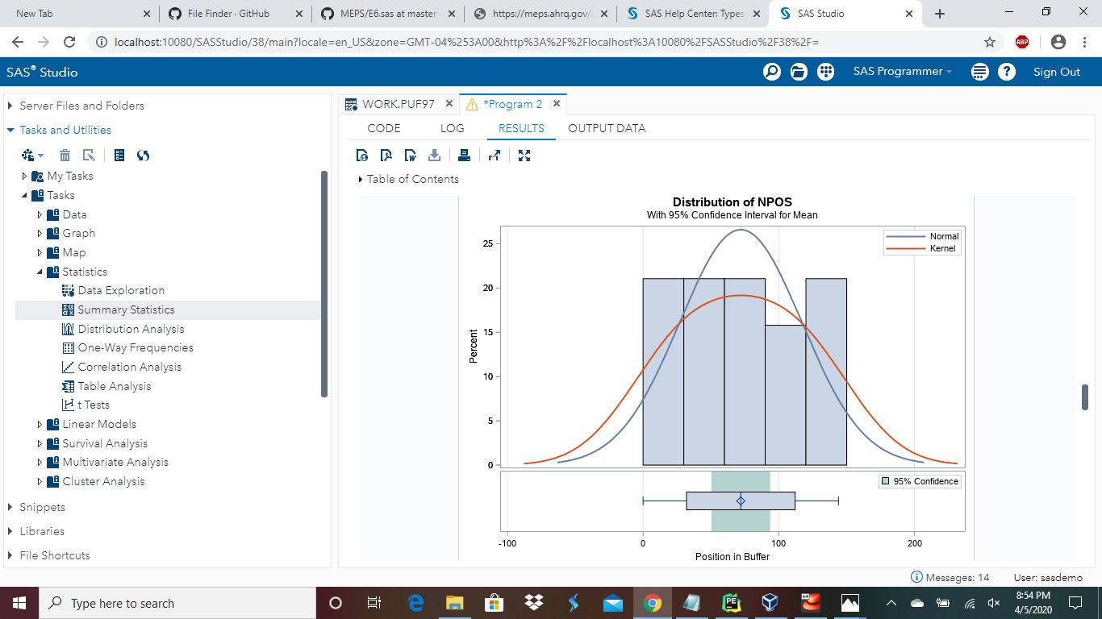

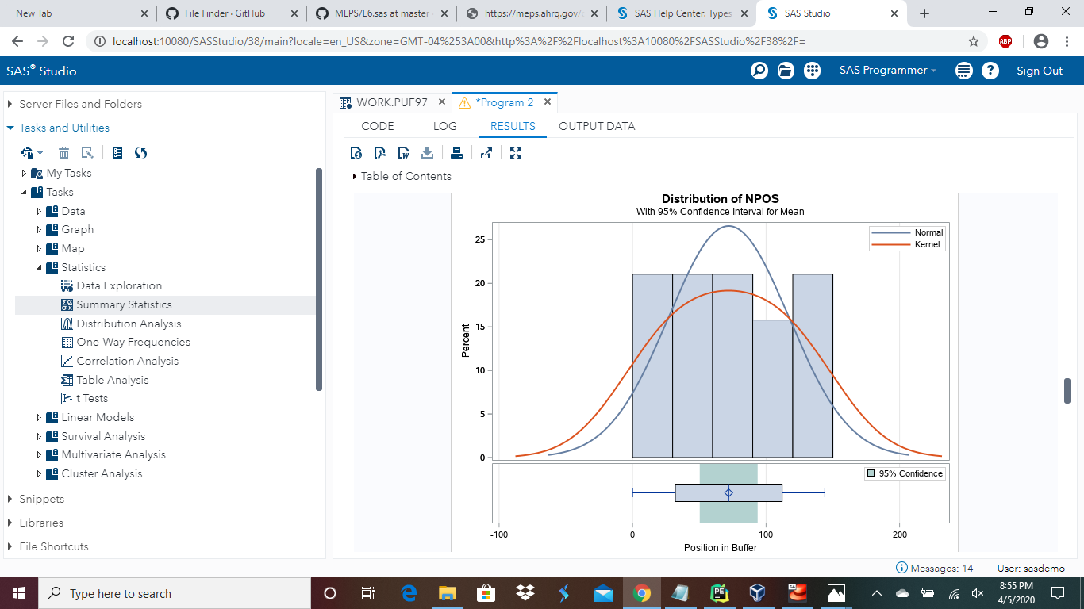

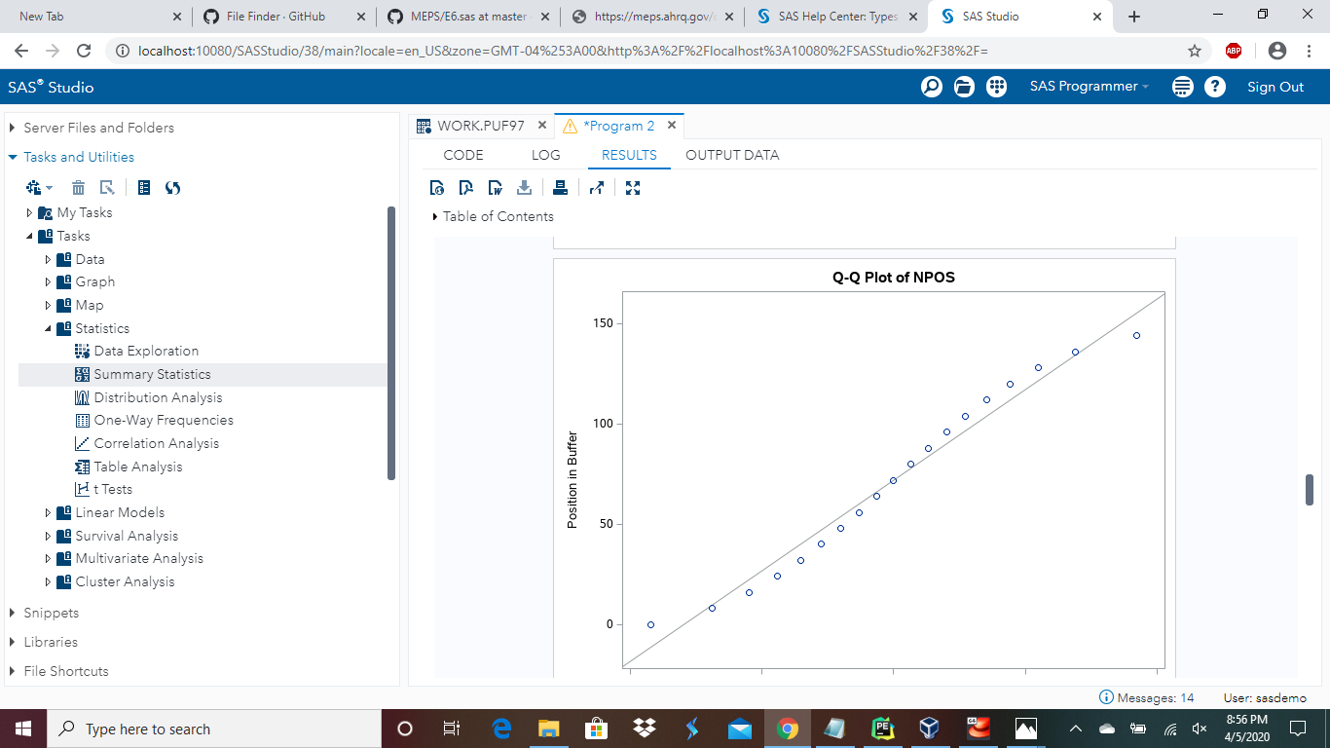

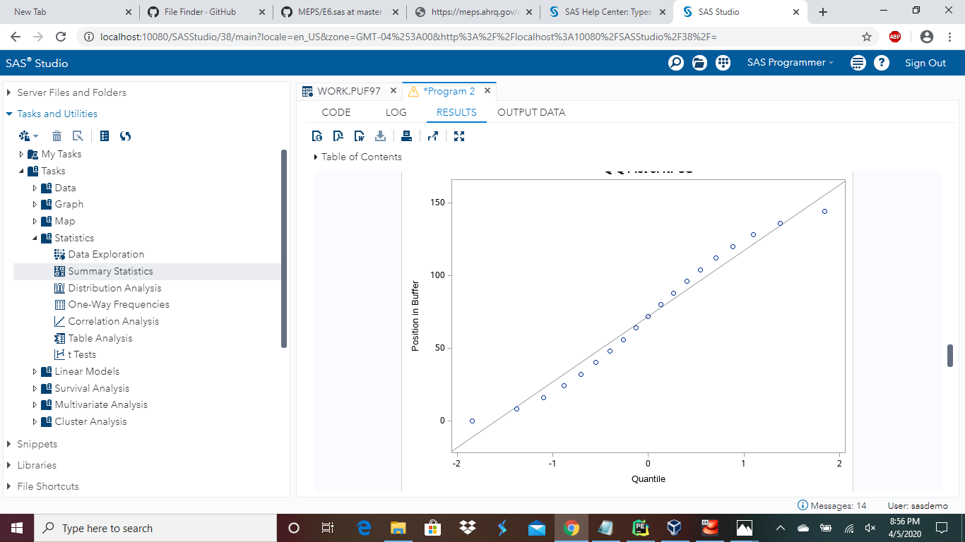

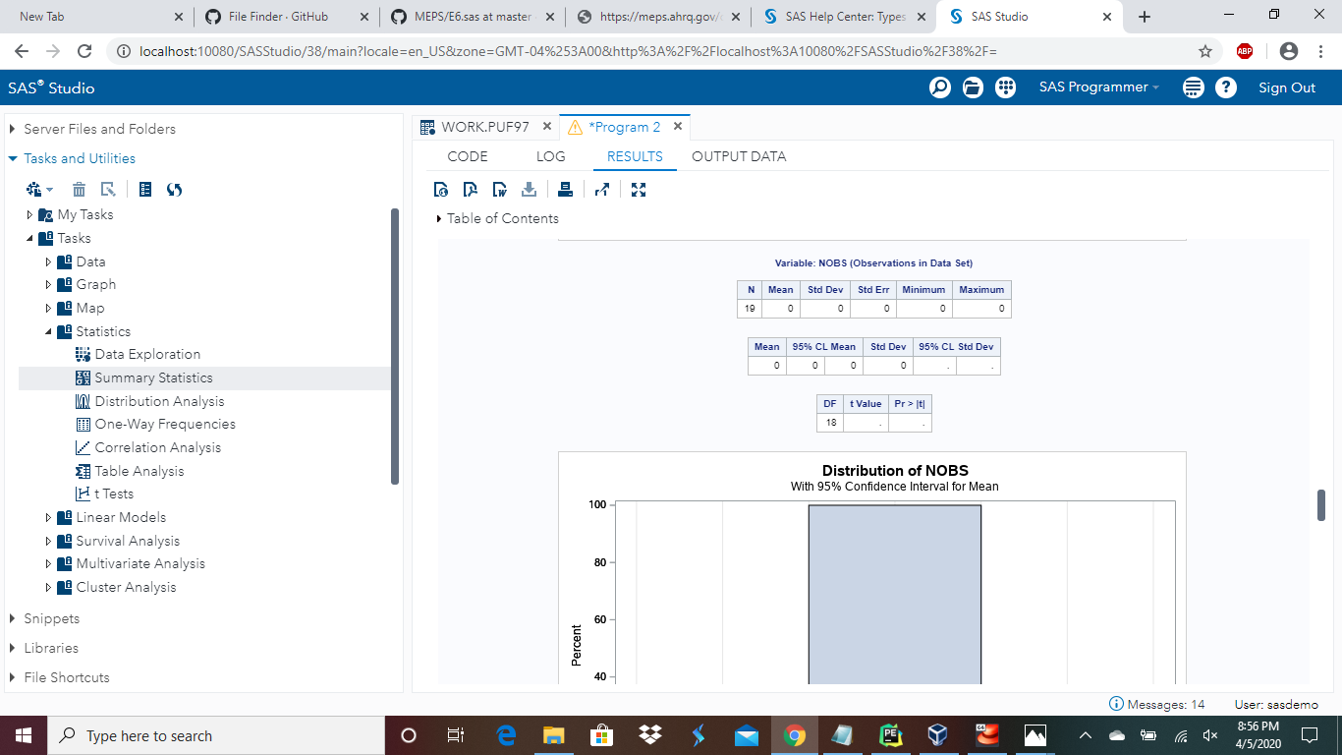

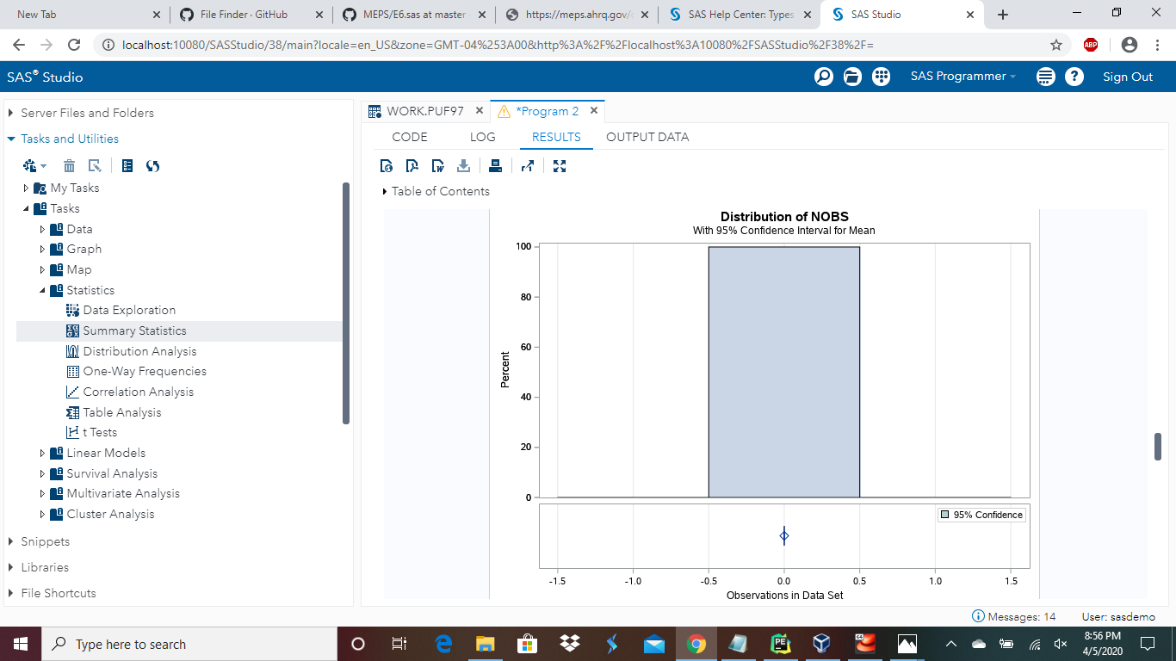

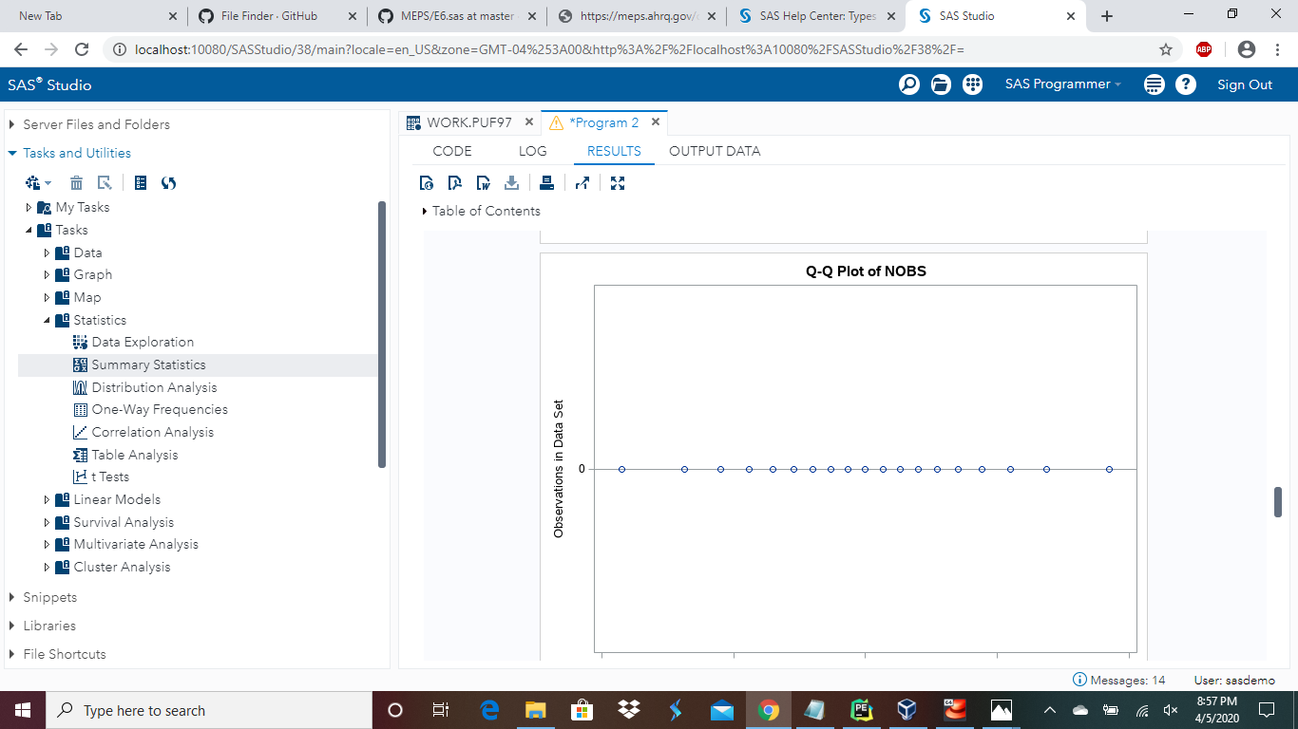

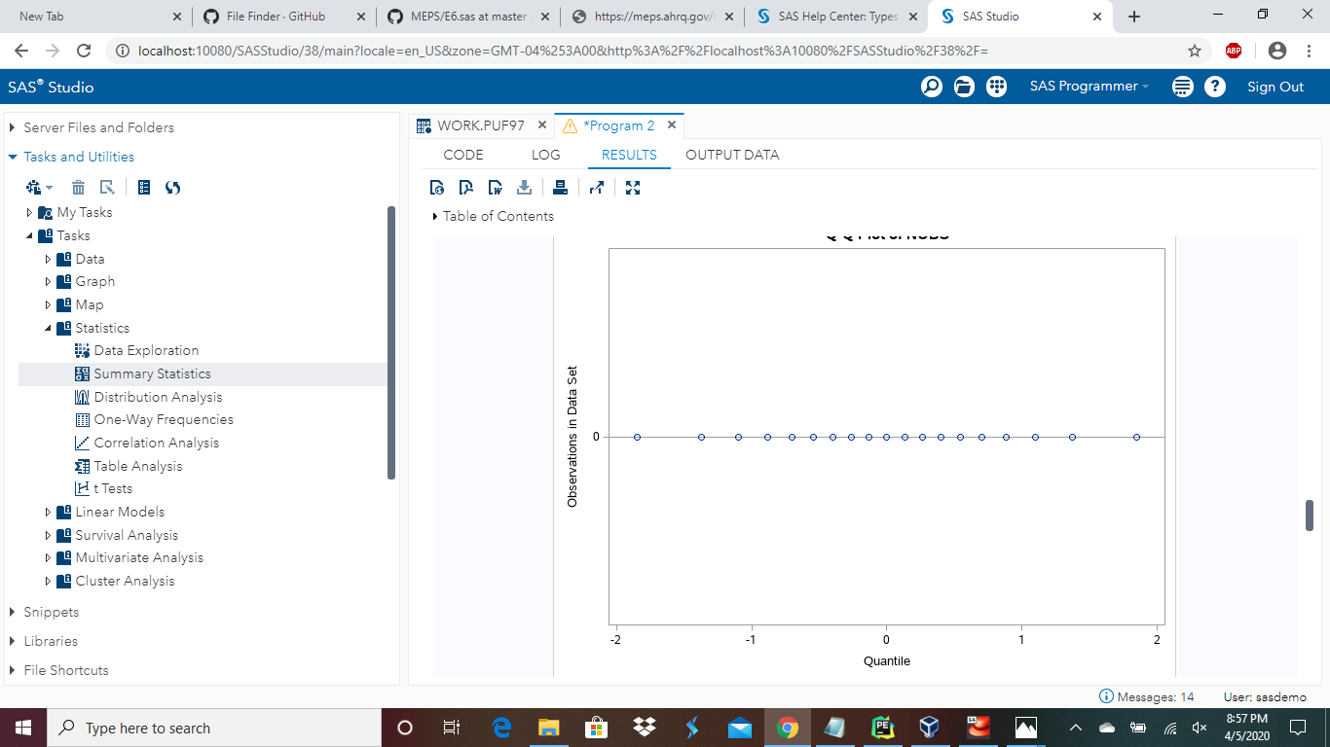

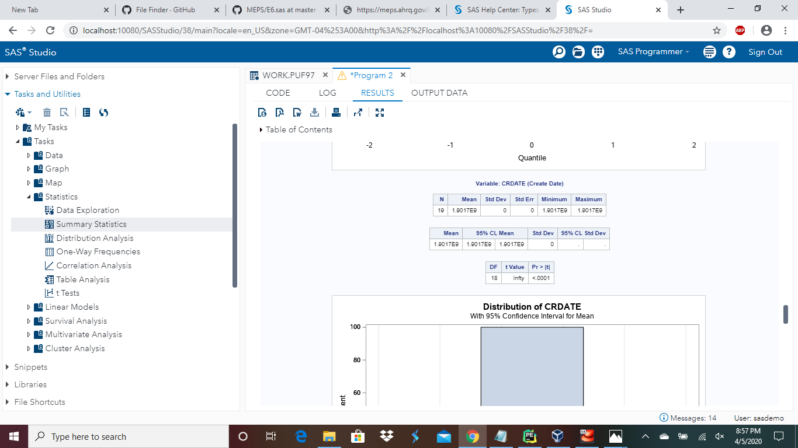

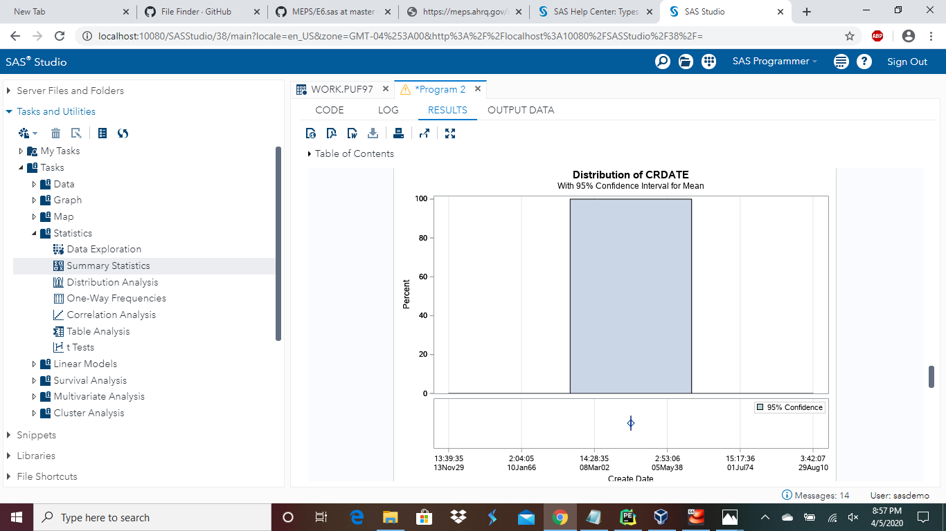

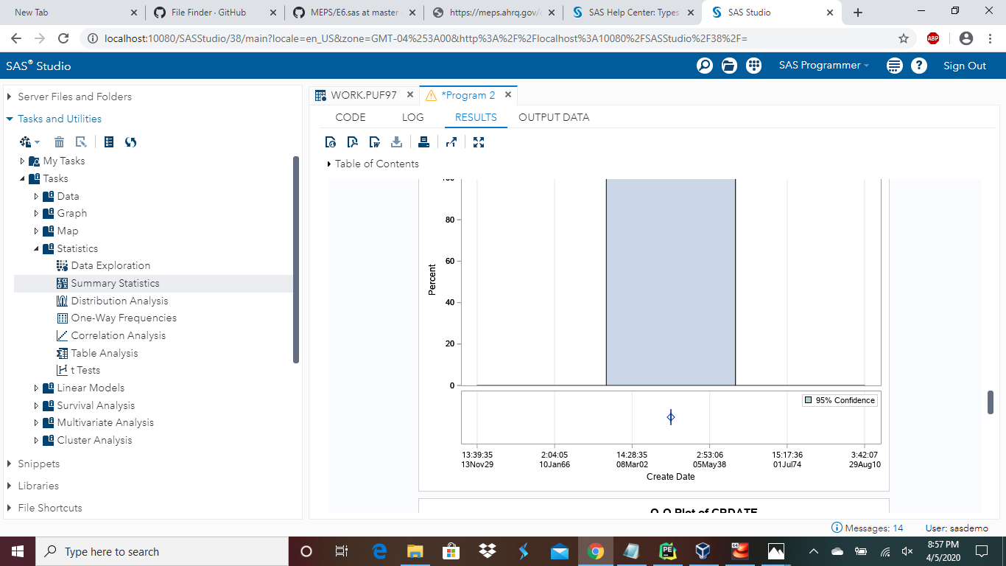

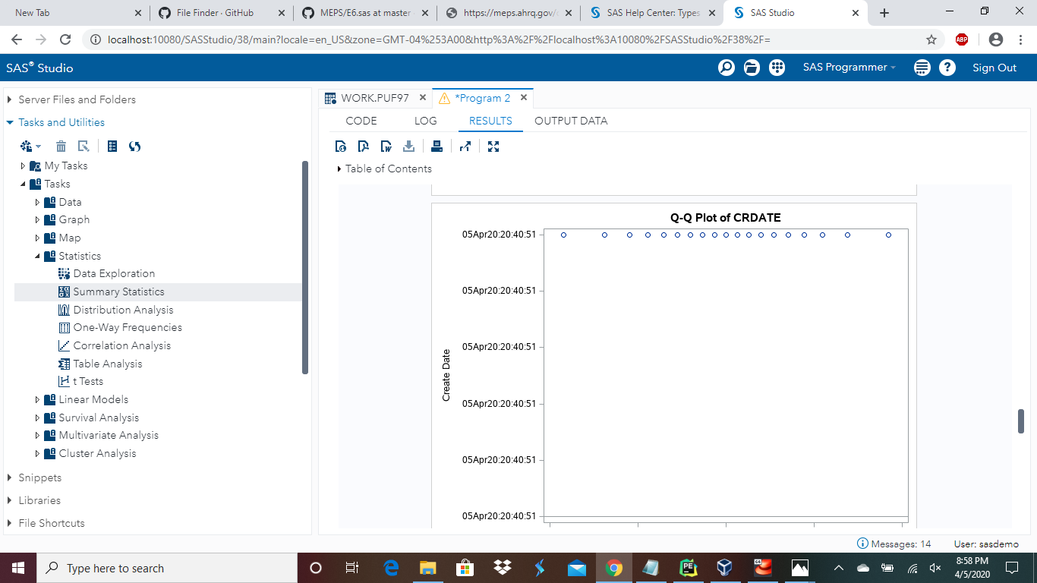

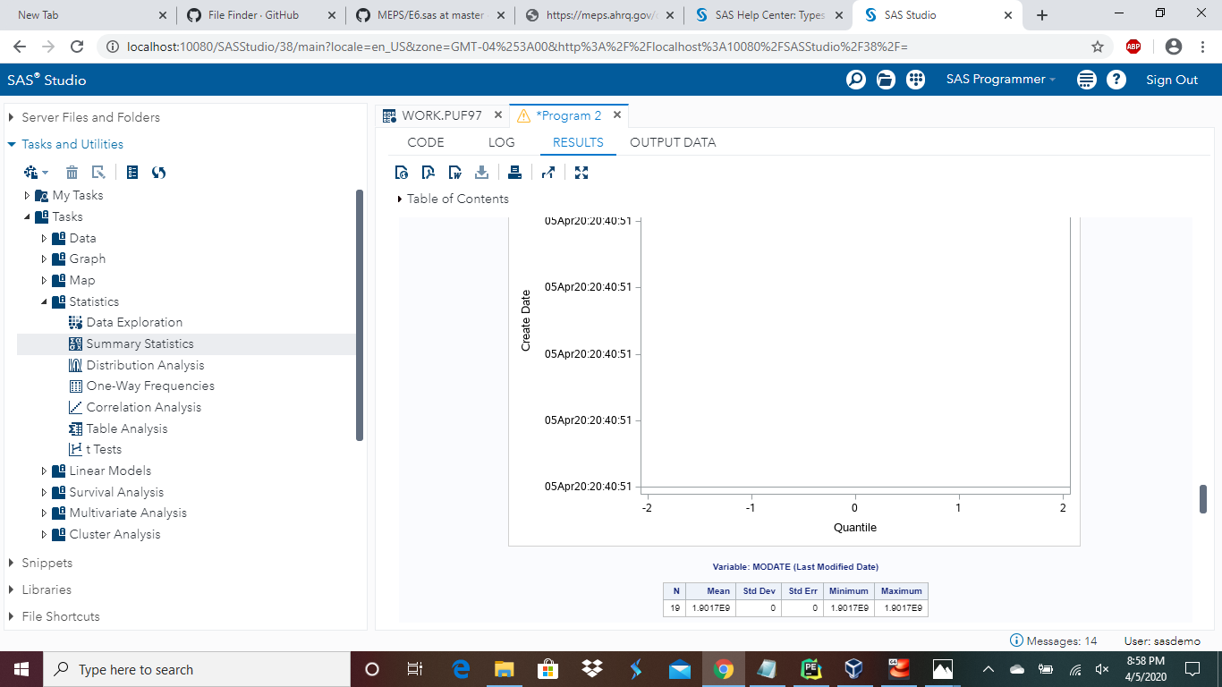

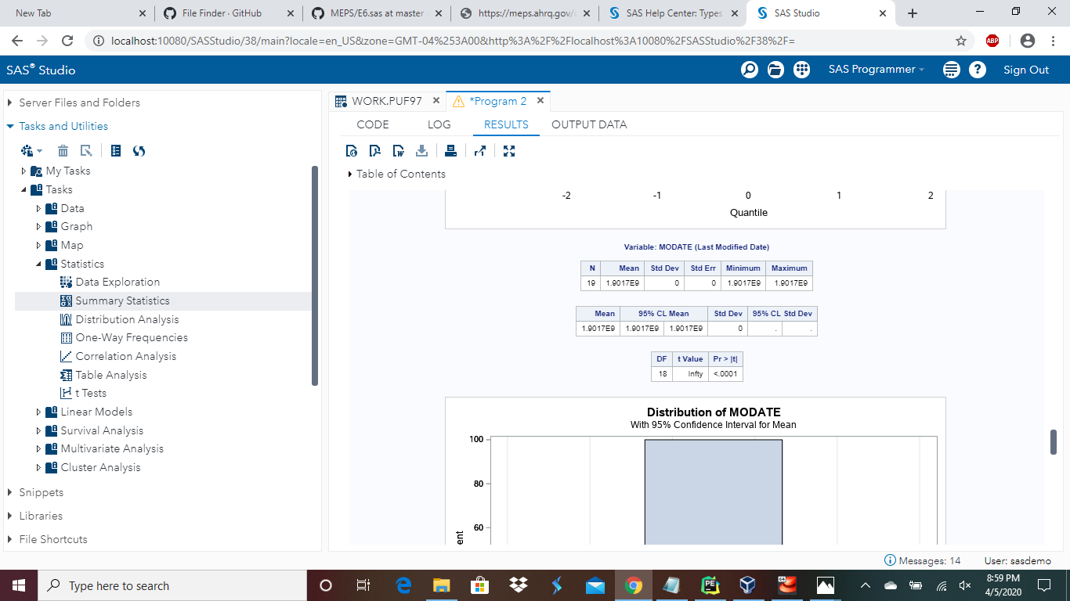

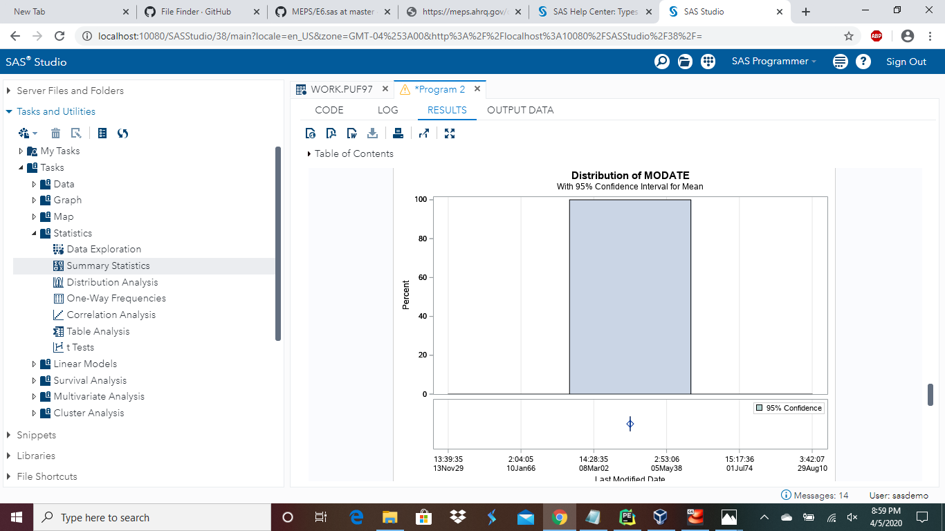

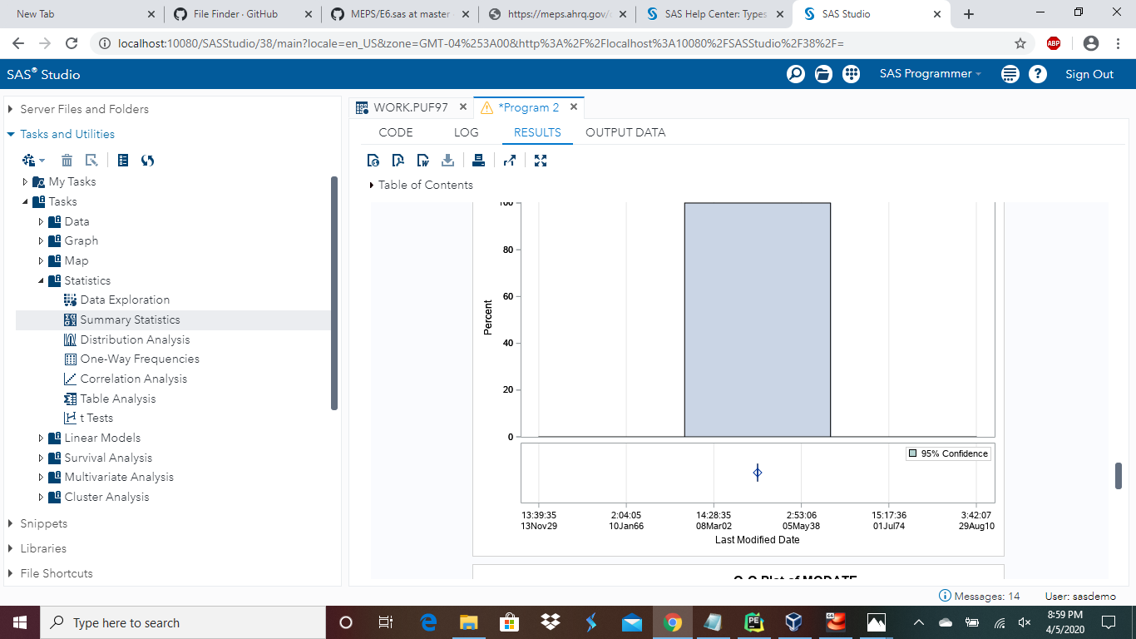

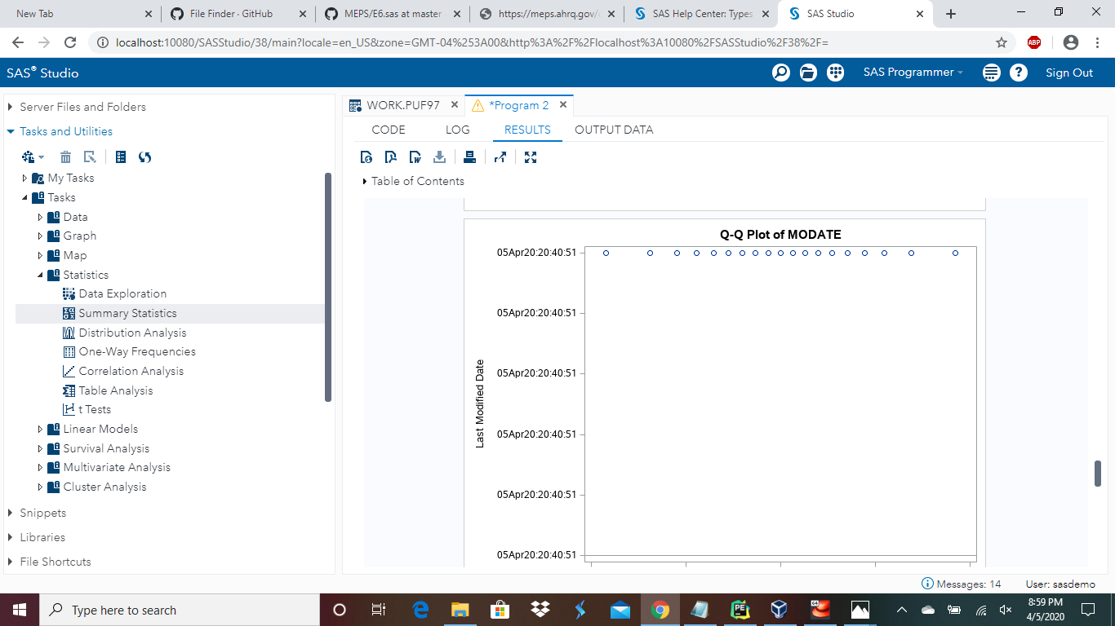

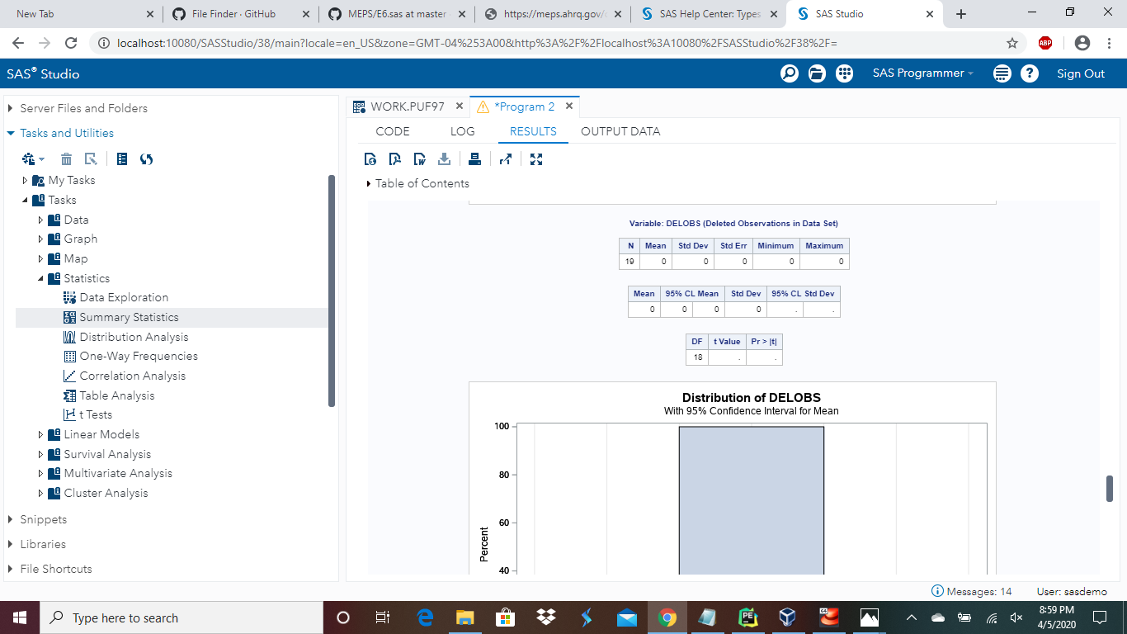

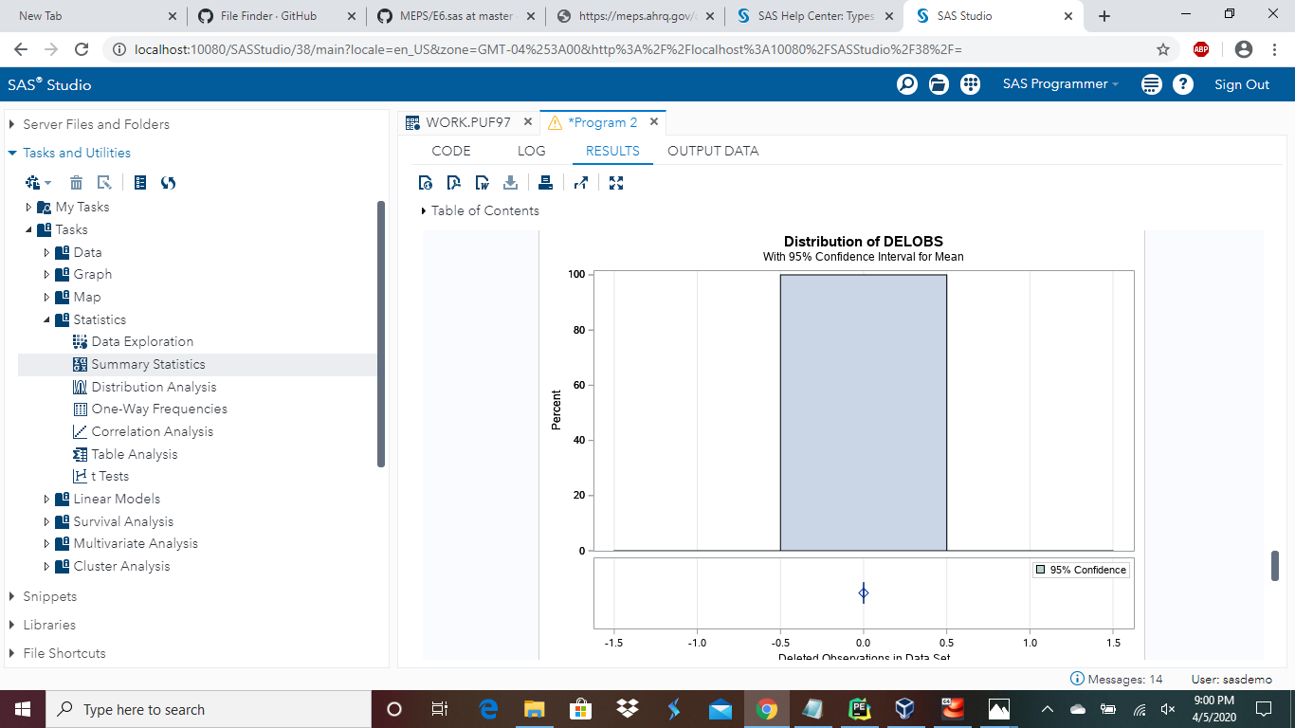

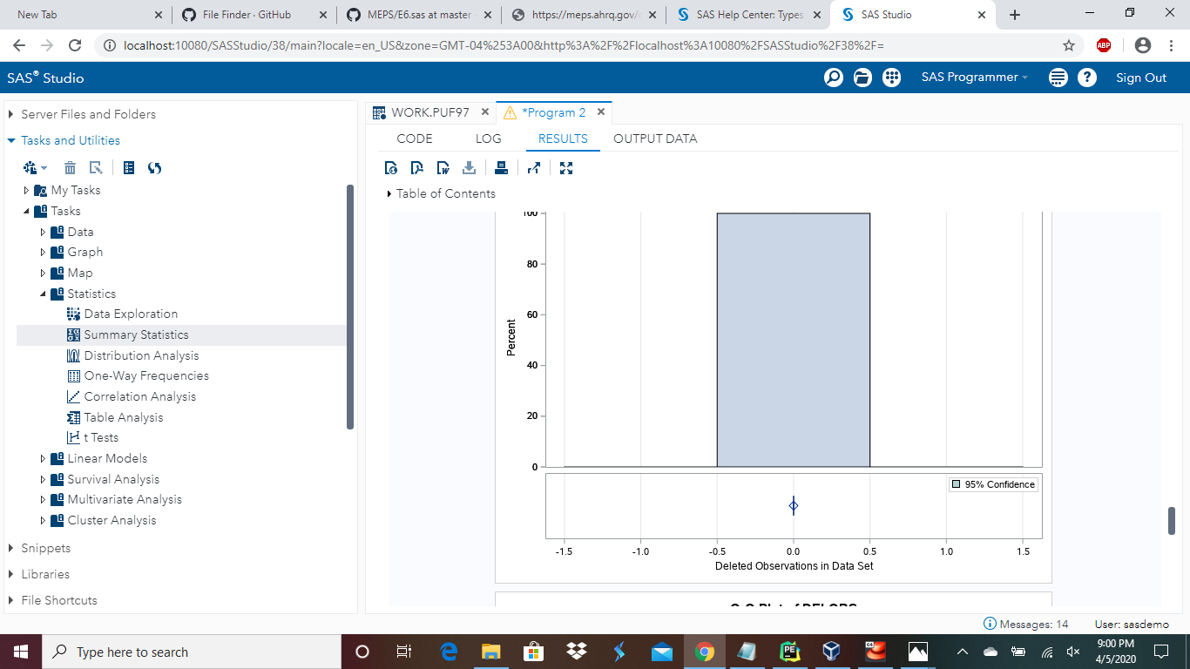

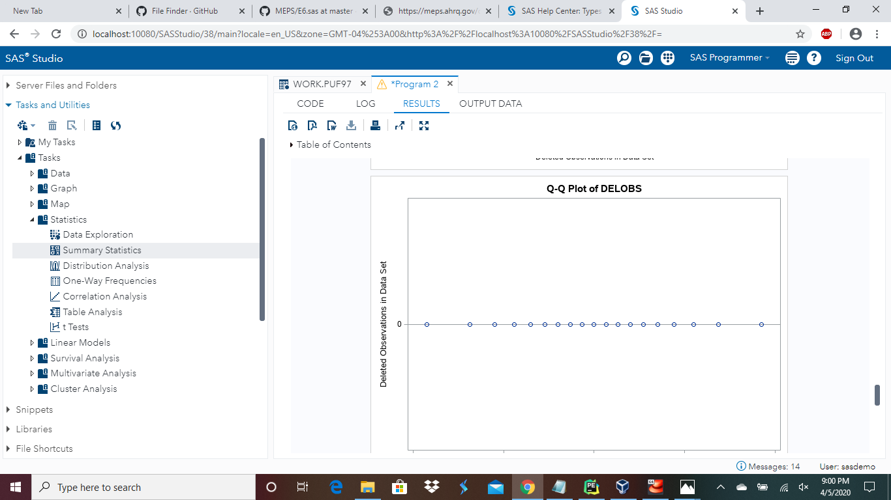

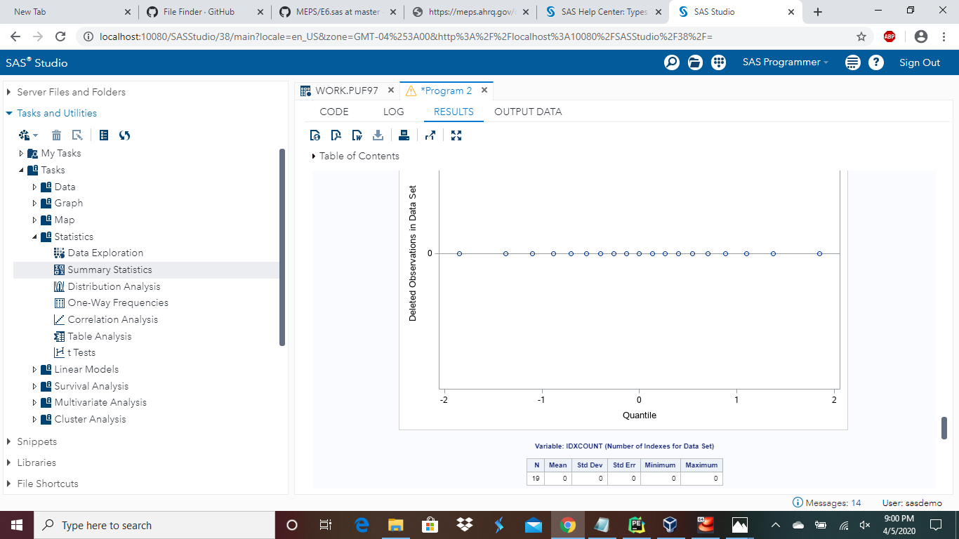

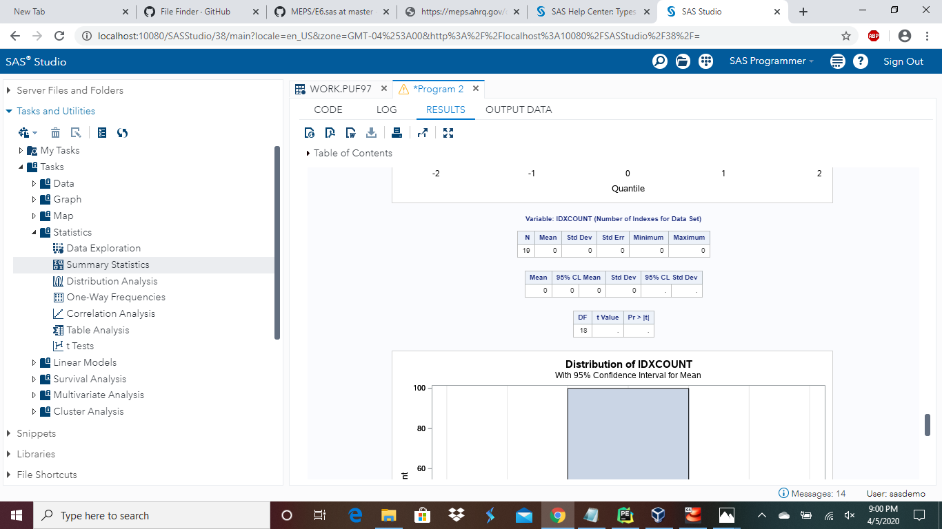

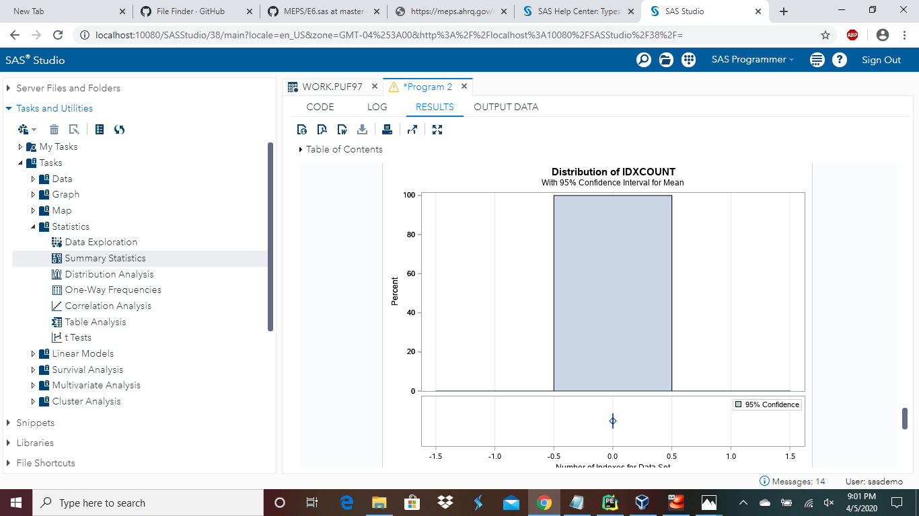

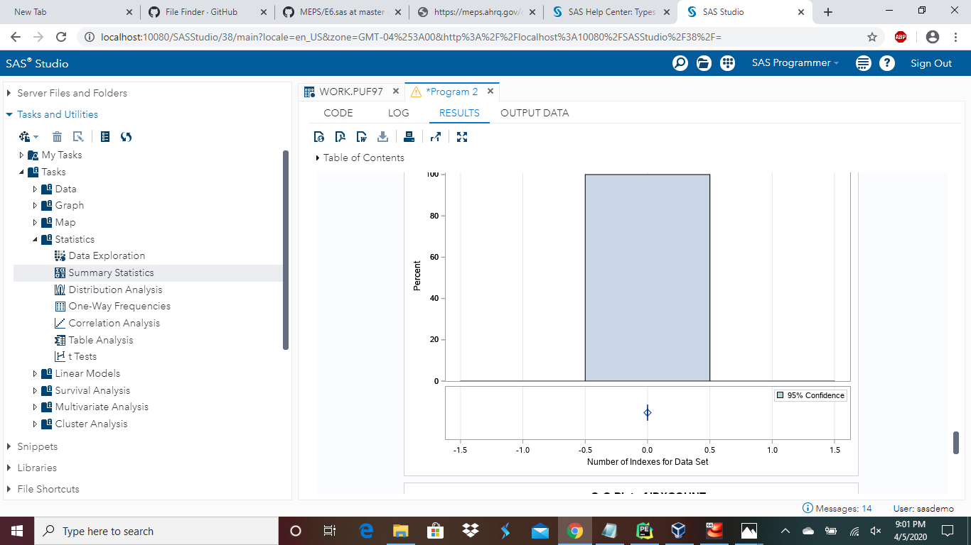

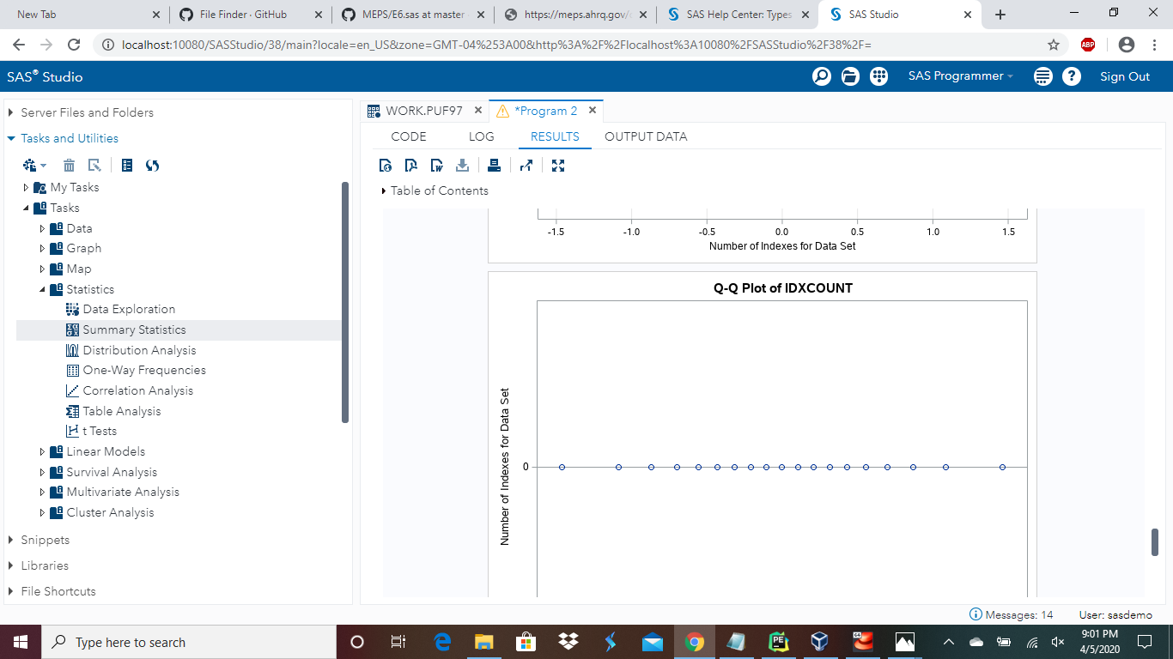

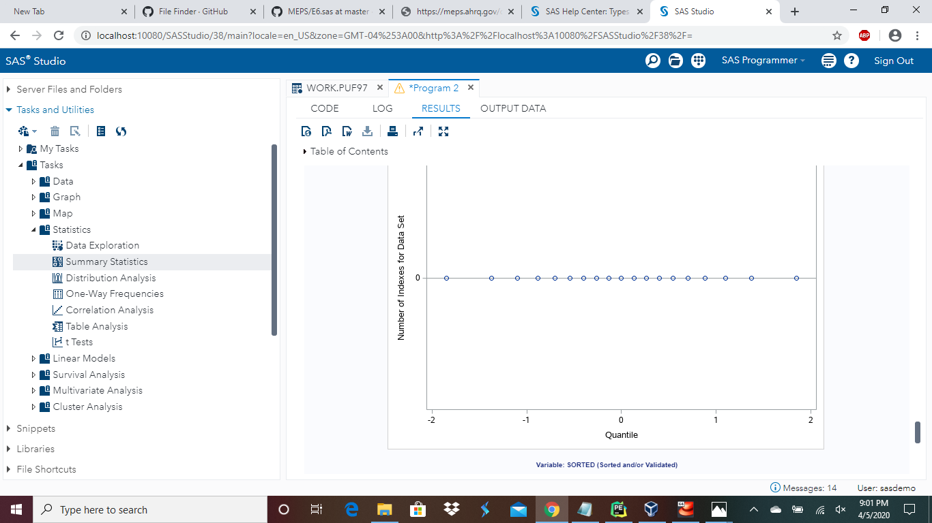

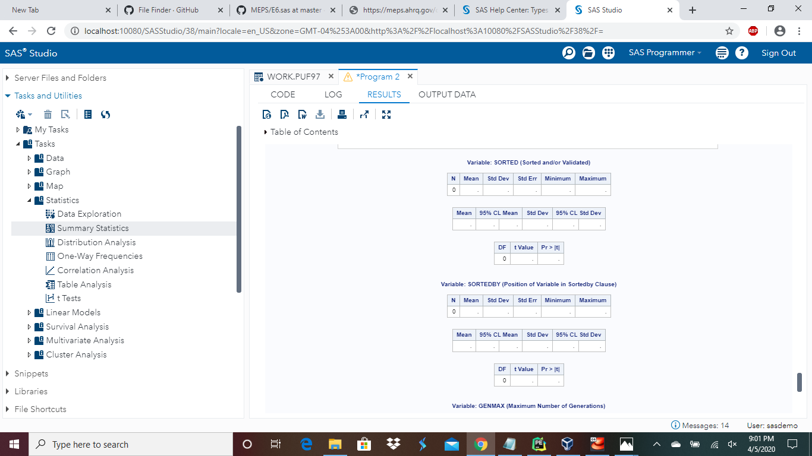

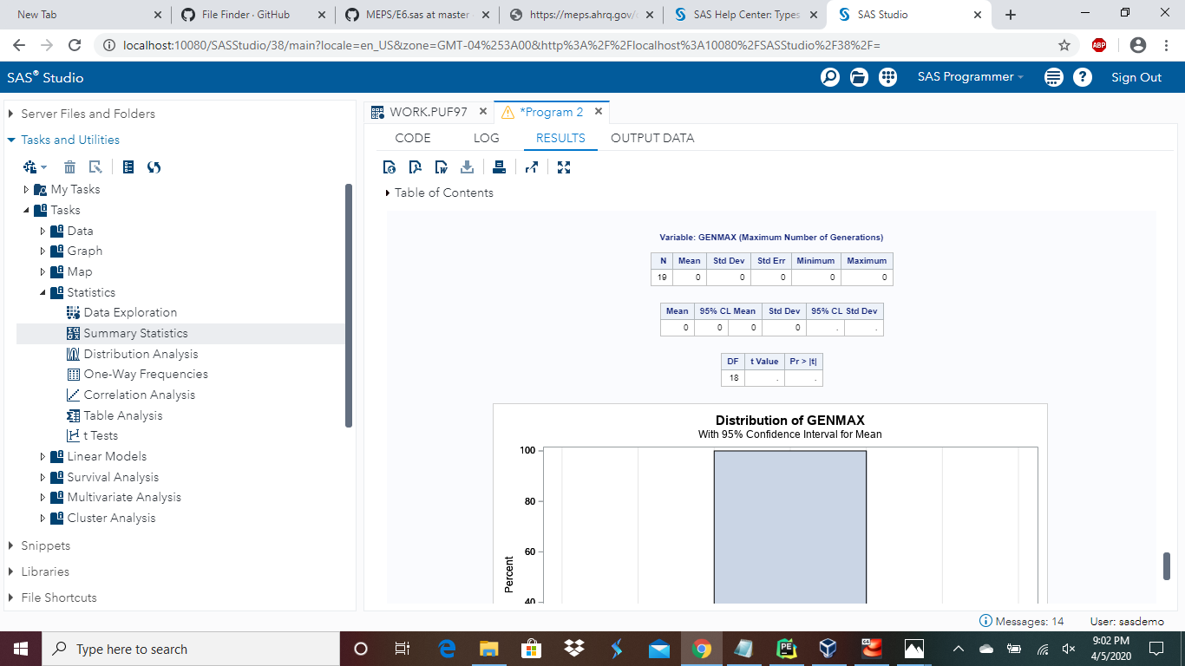

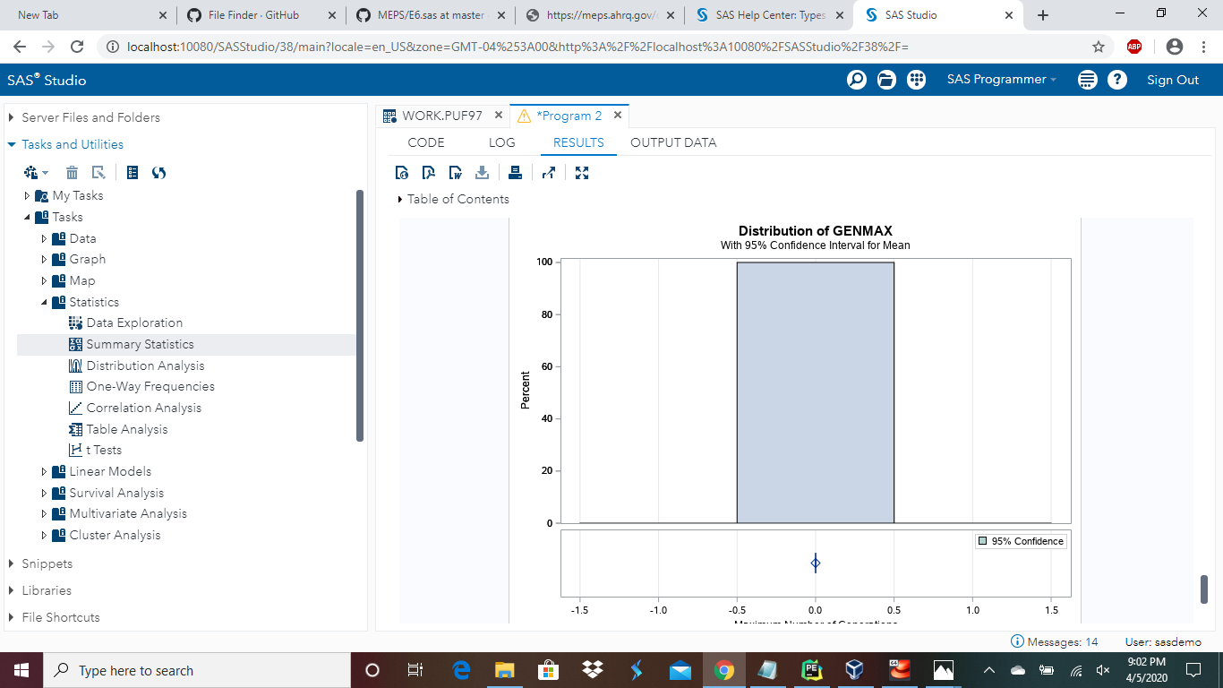

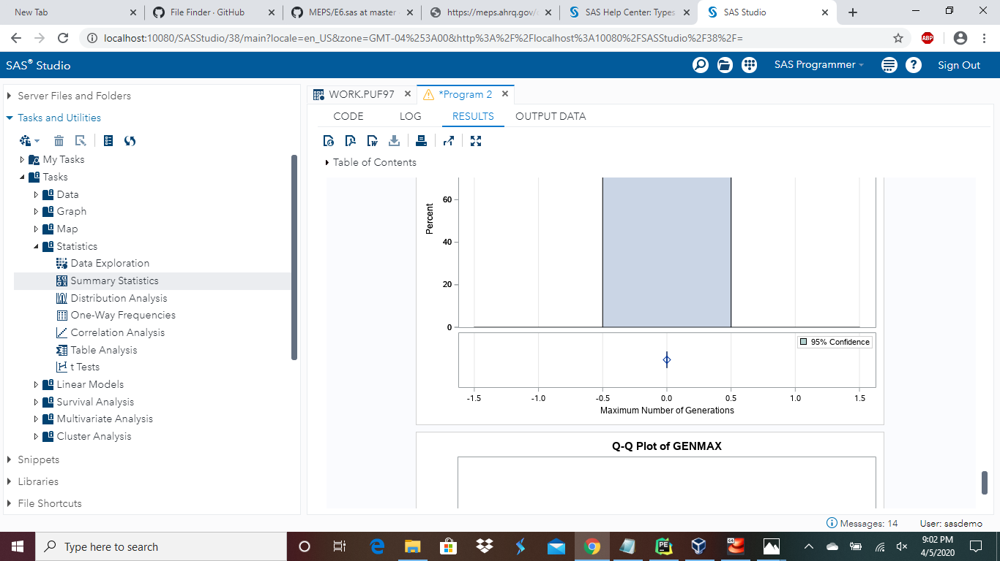

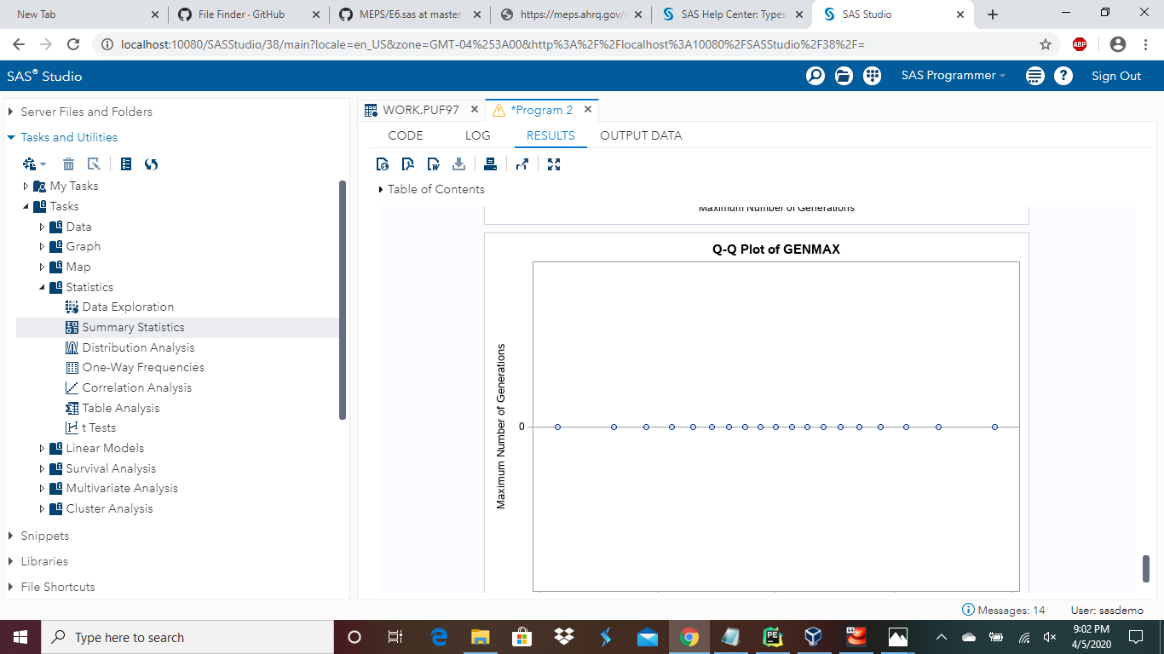

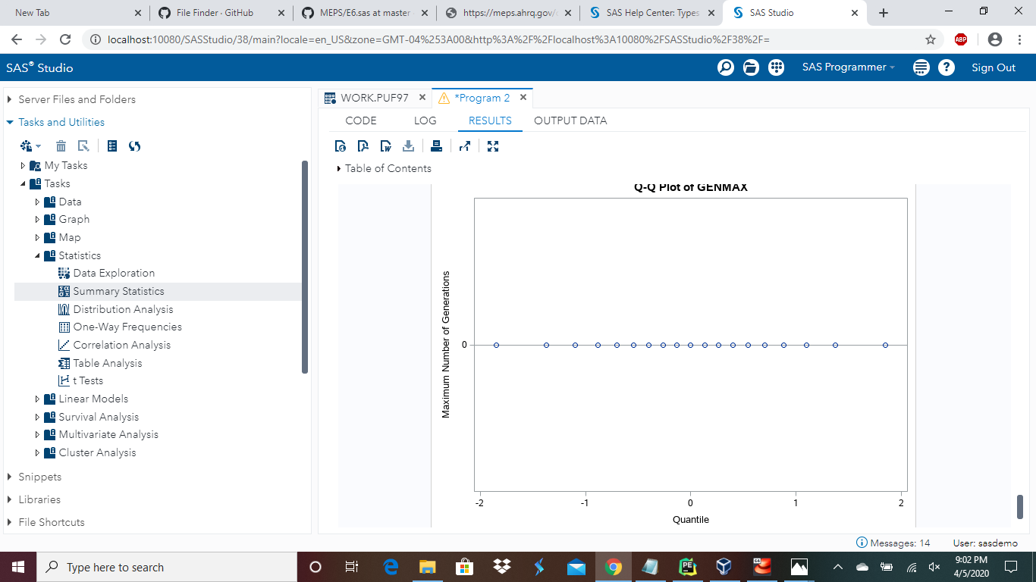

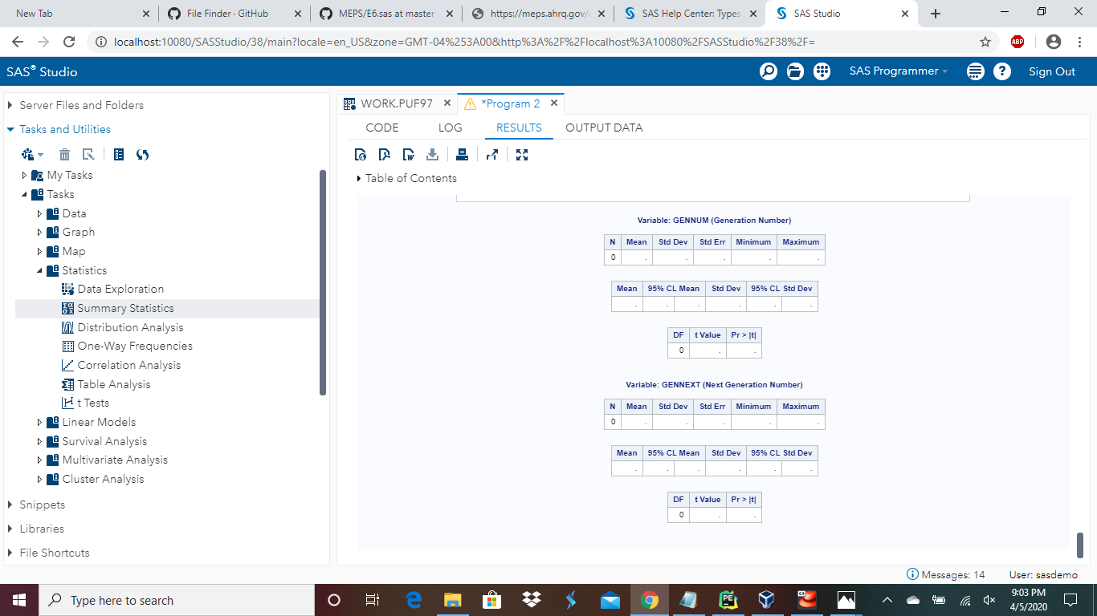

It comes as no surprise that the development in the healthcare field is frequently utilized to understand the limit between a developing and a developed nation. For example, the mortality rate of a nation determines the status of its healthcare system. The variety and the enormousness of the healthcare system majorly is dependent on the amount of the population of a nation. This is because the federal government decides likewise, so that the government can give healthcare needs to its masses.

Commonly, the healthcare system can be bifurcated into four different domains that provide as the foundation of this industry. The categorization is majorly completed on the base of various services and products they give. There are four different types of domains: healthcare services and facilities, manufacturer of medical devices, equipment, and hospital supplies, medical insurance, medical services, and managed care, and pharmaceuticals and related segments.

The first domain is the healthcare services and facilities. It plays a very essential role in the health industry. Hospitals provide a long systematic chain that gives various services to the society. There are various number of hospitals such as general medical hospitals, surgical hospitals, substance abuse and psychiatric hospitals, specialty hospitals, hospices and palliative care centers, family planning and abortion clinics, emergency and other outpatient care centers, dental laboratories, blood and organ banks, sleep disorder clinics, and etc.

The second domain is the manufacturer of medical devices, equipment, and hospital supplies. This is a huge and important industry that makes sure that there are smooth operations and delivery that is one time for the equipment and tools. The medical organizations that give the medical products and equipment are categorized under this specific section. Medical equipment created as per the latest technology, hospital supplies, products and services, and specialist functions are provided by these organizations. The everyday progression in science and technology in the medical fields aid in creating more innovative and helpful equipment, discovering procedures to diagnose and cure the ailments in an easier way.

The third domain is the medical insurance, medical services, and managed care. These are the friend industries to the healthcare industry. These companies which give medical insurance have become the initial and selected support for most of the treatments that have big expenses. They rely on hospitals, patients, and other medical services. One example is medical insurance. The facilities like no cash treatments create the treatment without any issues, and furthermore more and more patients are able to take treatment in the best possible type of hospital.

The organizations that give medical insurance and other various types of services to the patients or other medical sections come under this category. Some examples of medical insurance are medicare, dental insurance, medicaid, etc. Care management also comes under this category.

The definition of care management is a broad definition that is utilized for differentiating between various types of techniques that consist of decreasing the prices of the cost of health advantages and progress the quality of care for companies.

The fourth domain is the pharmaceuticals and related segments. This category majorly pays attention to development, manufacturing, and marketing pharmaceuticals which are allowed for usage as medicine. The necessity for inpatient and invasive care services can be deleted by this specific category.  These industries create and market drugs that can be allowed for usage and are effective as medicine. For example, a scientist having a job in drug creation and progression is a direct employee, while a chemist that is the owner of a shop and provides drugs to patients is an indirect employee. From drug wholesalers to drug retailers and sales agents, various other important players are active in this specific industry.

Well-known, with the rise in masses and the corresponding growth of health consciousness and demand, the creation of items like nutritional supplements is on the rise yearly. Various sections such as pharmaceutical, insurance, and medical equipment are growing to help this particular rising section. Hence, all sections in the healthcare industry are internally connected with each other.

For a long time, U.S. hospitals have paid attention to only raising money, volume, and progress. At the same time, the healthcare system has worthlessly spent hundreds of billions of dollars on supply chain unproductiveness, variety, service replicas, and sub labor management. Sadly, the healthcare price issue has entered the industry into a financial crisis.

In current times, Moody’s Investors Service reported that hospital average operating margins decreased to just 2.7 percent in the fiscal year 2016, and operating costs increased at a more rapid pace (7.5 percent) than operating profits (6.6 percent). To bring this issue in the limelight, healthcare systems need to change their business strategies to consist of paying more attention to the actual costs.

While systems can come up with various plans to affect profits and volume, the old-school techniques are antithetical to value based care. The profit side of the earnings math problem has altered, so hospitals need to also fix the cost side. Additionally, consumer costs for prescribed drugs are charged at double the price, and the costs for nursing homes and adult day services are over double the cost in current times. In comparison, consumer costs for all products rose only fifty percent over the same time period.

With increasing reduction plans, consumers are suffering more and more of the healthcare price issue. Healthcare systems need to view the fundamental reasons for rising costs and come up with smarter, creative resolutions to make the financial health better and thrive within value-based care.

The federal government uses almost $1.1 trillion on healthcare in the fiscal year 2018. Out of that, Medicare took away almost $583 billion, Medicaid and the Children’s Health Insurance Program took away almost $399 billion, and the veteran’s medical care about $70 billion. Furthermore, when looking at these direct scenarios, different tax sectors for healthcare decreased income tax money by about $225 billion. More than $146 billion of that specific amount comes from the involvement from the tax income of people who keep workers for jobs and their contributions towards the medical insurance rising costs and medical care. The non-involvement of the contributions from people who keep others for work towards the medical care also eventually decrease payroll taxes, even though that effect is not within the official tax reduction approximations. Which includes the effectiveness on both the money and the payroll taxes, the exclusion decreased the government money by $280 billion in 2018.

Current price systems, which estimate the prices of individual departments, services, or support activities, often support the moving of prices from one type of service or provider to another, or to the customers themselves. The minimal management of the prices at the individual company level does only so much to decrease the overall price or improve the total value – and may also demolish the value by lessening the effect of care and moving up the administrative costs. Any correct pricing system must, at a basic level, take into consideration for the overall costs of all the resources used by a patient as she or he progresses towards the system.

The cost problem and the third domain of the healthcare system are also valid reasons for why I chose to complete this Portfolio Project by selecting the national healthcare expenditure by the type of service SAS code example.

When I first started this Portfolio Project, I was in confusion as to how to modify the SAS code example. However, after thinking about a past critical thinking assignment from this specific course, I thought of using the PyCharm Edu program to help me modify this particular SAS code example.

When I put the SAS code example into the PyCharm Edu file that I had created, there were various errors, warnings, and typos that needed to be corrected in the given code. For this code, there were a total of 305 errors, 70 warnings, and 9 typos to begin with. For me, this was the most time-consuming part of the whole project. However, through the process of research, logic, and common sense I ended up correcting the errors that were present in the given code.

After the code was modified, I copy and pasted the corrected code into the SAS program and ran the code. The code ran and I was able to see the given results. Then, for the next step I researched the code for the SAS summary statistics and the two t-tests. After finding these two codes through research, I was able to insert both codes and get the given results. After, I added a visual graph to show the change over time in the national healthcare expenditure by the type of service with the SAS code example. Finally, I took screenshots as per the directions of this specific project and tailored my assignment as per the required APA style format.

There are various ways to help the issue of national healthcare expenditure in an overall perspective. The first solution could be to discard paper records for patient files and switch to technology. Another possible solution could be to change marketing strategies of using the television and print ads to using technology instead to market. The third solution could be more for the patients themselves rather than the healthcare givers. Finally, as the third solution, the patients could reconsider retirement options and also think about buying long-term care insurance. Both the issues and solutions for this or any field in this case are endless. It is the mentality of the masses as to how they would like to approach field progression and issues with the present growing technology of today’s times for the betterment of themselves, the industry, and the society.

Overall, this Portfolio Project was challenging. It was not as easy as it may seem. I would sit and think how to proceed with the next step of the project at times and would end up with blank space. It made me push myself to give my best even in times when I did not know how to give it all of my efforts. However, through this project I learned a lot which makes my work towards this specific project all the more worthwhile.

References

Analyzing MEPS data using SAS (2020). In *Github*. Retrieved from <https://github.com/HHS-AHRQ/MEPS/tree/master/SAS#sas-examples>

Brown, B., & Hansmann, J. (2018, January 11). Five Solutions to Controlling Healthcare’s Cost Problem. In *Health Catalyst*. Retrieved from <https://www.healthcatalyst.com/healthcare-cost-problem-how-to-control-it>

Conklin, T. P. (2002). Health Care in the United States: An Evolving System. In *Michigan Family Review*. Retrieved from <https://quod.lib.umich.edu/m/mfr/4919087.0007.102/--health-care-in-the-united-states-an-evolving-system?rgn=main;view=fulltext>

Download Data Files, Documentation, and Codebooks (2019, January 3). In *AHRQ*. Retrieved from <https://meps.ahrq.gov/mepsweb/data_stats/download_data_files.jsp>

How much does the federal government spend on health care? (n.d.). In *TPC*. Retrieved from <https://www.taxpolicycenter.org/briefing-book/how-much-does-federal-government-spend-health-care>

The Big Idea: How to Solve the Cost Crisis in Health Care (n.d.). In *Harvard Business Review*. Retrieved from <https://hbr.org/2011/09/how-to-solve-the-cost-crisis-in-health-care>

Wilson, N. (2019, July 17). An Overview of Key Sectors of Healthcare Industry. In *Medium*. Retrieved from <https://medium.com/@neil.wilston123/an-overview-of-key-sectors-of-healthcare-industry-d507823da03f>

4 Massive Healthcare Management Problems (and Solutions) (2020). In *BFW*. Retrieved from <https://www.bfwinc.com/healthcare-management-problems/>